**SUBMITTED BY:** Prachi Aggarwal

**COURSE:** Bsc(H) Computer Science

**ROLL NO:** 21570015

**SUBJECT:** Web Development and Design

**UNIQUE PAPER CODE:** 32343306

**SEMESTER:** IIIrd

**YEAR:** 2nd

**SUBMITTED TO:** Ms. Kanishka

**Examination Rollno:** 21033570042

**TOPIC:** Practical File

**HTML + CSS**

**HTML: Q1)**

**Create an HTML Page showing information about your favorite movie in following manner: a. Name of the movie as the heading in center as well as title of page. b. One paragraph stating the information about movie like release date, genre, director, budget etc. c. At least two images of the posters of movie. d. One paragraph describing the plot of the movie. e. An unordered list stating the cast of the movie along with equal size photos. f. An ordered list stating similar movies linking to corresponding Wikipedia pages. g. All segments must be separated by different levels of headings.**

**CSS: Q1)**

**Redesign page created in HTML practical 1 such that: a. All images have a solid red border of 1px width. b. All headings should be in dark blue color. c. Text of paragraph must be of different font-family than the complete page. d. Background color of the page should be aqua.**

**Ans) Html file**

<html>

<head><title>Zootopia</title>

<link rel="stylesheet" href="Q1.css">

</head>

<body style="border: 5px solid black;">

    <h1 style= "font-size:100; font-family:arial; text-align: center; text-color:blue;"><b><u>Zootopia</u></b></h1>

<center><img src="https://th.bing.com/th/id/OIP.nzT8uRm7X4N6gue5_SfJ7gHaEK?w=323&h=181&c=7&r=0&o=5&pid=1.7" alt="not available" width="400" height="400" ></center>

    <img style=" margin-left:250px; margin-top:50px;" src="https://th.bing.com/th/id/OIP.lcWO68IfMGw9hzBopviGsAHaLH?w=196&h=294&c=7&r=0&o=5&pid=1.7" width = "300" height="300"><img style="margin-top:50px;" src="https://th.bing.com/th/id/OIP.uAaN-G-56LwfylqacntM0gHaEM?w=293&h=180&c=7&r=0&o=5&pid=1.7" alt="not" widht="200" height="200"><img style="margin-top:50px;" src="https://th.bing.com/th/id/OIP._LO55dYmoKY15WR7l2rDBgHaLH?pid=ImgDet&rs=1" width="300" height="300" >

    <br>

    <h3><i><strong>Description</strong></i></h3>

<p><b>Production:</b> Walt Disney Animation Studios<br>

<b>Generes:</b> Action, Adventure, comedy , crime , animation ,family<br>

<b>Country:</b> USA<br>

<b>Languages:</b> English, Norwegian<!--<img src="https://th.bing.com/th/id/OIP.llZWJxI1MXEuQEhuaqqUwQHaHa?pid=ImgDet&rs=1" alt="not" width="200" height="200" align="right">--><br>

<b>Release Date:</b> Jun 7, 2016<br>

<b>Director:</b> Byron Howard, Jared Bush, Rich Moore<br>

<b>Producer:</b> Clark Spencer, Brad Simonsen</p>

    <h2><i>Plot</i></h3>

    <p class="para">Zootopia is a 2016 American computer-animated buddy cop action-comedy film produced by Walt Disney Animation Studios and released by Walt Disney Pictures. The 55th Disney animated feature film, it was directed by Byron Howard and Rich Moore, co-directed by Jared Bush, and produced by Clark Spencer, with a screenplay written by Bush and Phil Johnston, and a story by Howard, Moore, Bush, Johnston, Jim Reardon, Josie Trinidad, and Jennifer Lee.

    From the largest elephant to the smallest shrew, the city of Zootopia is a mammal metropolis where various animals live and thrive. When Judy Hopps becomes the first rabbit to join the police force, she quickly learns how tough it is to enforce the law. Determined to prove herself, Judy jumps at the opportunity to solve a mysterious case. Unfortunately, that means working with Nick Wilde, a wily fox who makes her job even harder.

    Being the first one is never easy, especially for Judy Hopps, the first bunny cop. When strange things happen in the city, Judy decides that she will try to solve the case, but she only has 48 hours to do so. To help her, she partners with a con artist fox named Nick Wilde, even though he makes the job harder.</p>

    <h2><i>Casts</i></h3>

    <ul>

    <li><img src="https://th.bing.com/th/id/OIP.KvCOLf56ZiICB62ys_Pm8AHaKi?pid=ImgDet&rs=1

    " alt="not" width="100" height="100">Ginnifer Goodwin</li>

    <li><img src="https://th.bing.com/th/id/OIP.AmlBcwjDzKs6gkve1WMiHgHaK5?pid=ImgDet&rs=1

    " alt="not" width="100" height="100">Janson Bateman</li>

    <li><img src="https://th.bing.com/th/id/OIP.7PxbWUb0Byg9yVz--BoFMAHaF7?pid=ImgDet&rs=1" alt="not" width="100" height="100">Ginnifer Goodwin</li>

    <li><img src="https://th.bing.com/th/id/OIP.ASYvWFvCisuKlWvUjpBvUAHaJ7?pid=ImgDet&rs=1" alt="not" width="100" height="100">Irdis Elba</li>

    <li><img src="https://th.bing.com/th/id/OIP.rKz-v0jzyCI6KZBaudEF3QHaE7?pid=ImgDet&rs=1" alt="not" width="100" height="100">Nate Torrence</li>

    <li><img src="https://th.bing.com/th/id/OIP.yM_r27wsWq4mkZYLIm43IQHaJ2?pid=ImgDet&rs=1

    " alt="not" width="100" height="100">Bonnie Hunt</li>

    </ul>

    <h2><i>Related links</i></h3>

    <ul>

    <li><img src="https://th.bing.com/th/id/OIP.EJb-cmSp0CGW6-O2JIFSHgHaFj?pid=ImgDet&rs=1" alt="not" width="150" height="200"><a href="https://en.wikipedia.org/wiki/The_Incredibles" target="_blank">The Incredibles</a></li>

    <li><img src="https://th.bing.com/th/id/OIP.5Zhb1LCmELYiLJd-rJ01AAHaFM?pid=ImgDet&rs=1" alt="not" width="150" height="200" target="_blank"><a href="https://en.wikipedia.org/wiki/Princess_Mononoke" target="_blank">Princess Monoke</a></li>

    <li><img src="https://th.bing.com/th/id/OIP.tv6qqUk0OnDZ2_3KwSJO0QHaKb?pid=ImgDet&rs=1" alt="not" width="150" height="200"><a href="https://en.wikipedia.org/wiki/The_Lion_King" target="_blank">The Lion King</a></li>

    <li><img src="https://th.bing.com/th/id/OIP.spij0yGOBUeNopk3wdJpYgHaHa?pid=ImgDet&rs=1 " alt="not" width="150" height="200"><a href="https://www.bing.com/search?q=inside+out&FORM=HDRSC1" target="_blank">Inside out</a></li>

    <li><img src="https://th.bing.com/th/id/OIP.EkXk5MKOQR9PYdevJ-j74QHaLH?pid=ImgDet&rs=1" alt="not" width="150" height="200"><a href=" https://en.wikipedia.org/wiki/Big_Hero_6_(film)" target="_blank">Big Hero 6</a></li>

    <li><img src="https://th.bing.com/th/id/OIP.i-4p6VhCO9XaoyJ35uudwwHaEK?pid=ImgDet&rs=1" alt="not" width="150" height="200"><a href="https://en.wikipedia.org/wiki/The_Boss_Baby" target="_blank">Boss Baby</a></li>

    <li><img src="https://th.bing.com/th/id/OIP.rpOT5bbltoILoNgV5a_0SAHaKv?pid=ImgDet&rs=1" alt="not" width="150" height="200"><a href="https://www.bing.com/search?q=kung+fu+panda&FORM=HDRSC1" target="_blank">Kung Fu Panda</a></li>

    </body>

</html>

**Css file**

img{

    border: 1px solid red;

}

h1,h2,h3{

    color:darkblue;

}

.para{

    font-family: fantasy;

}

body{

    background-color: aqua;

}

**OUTPUT**

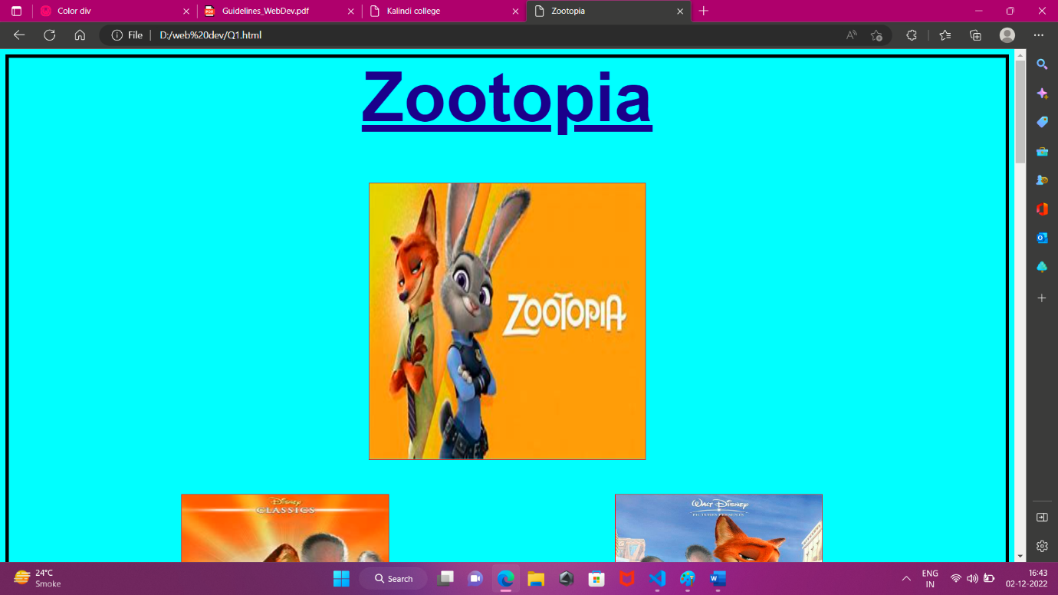

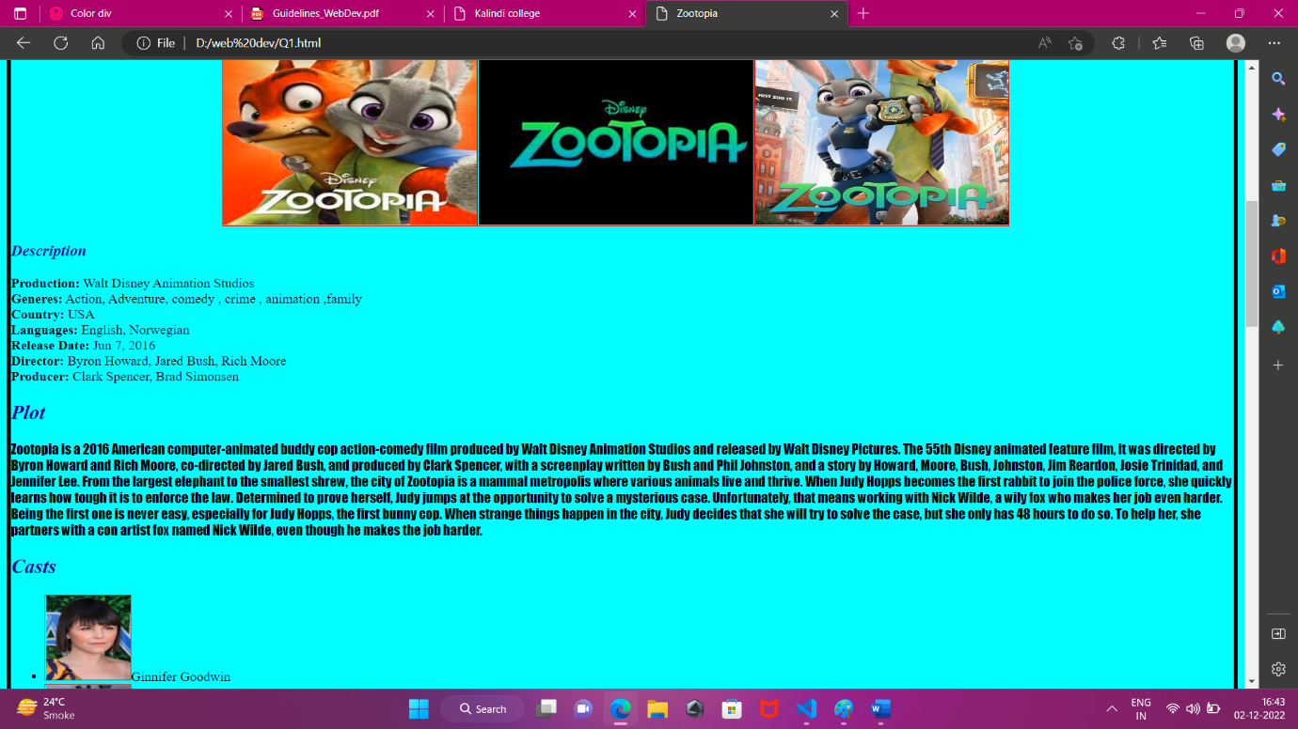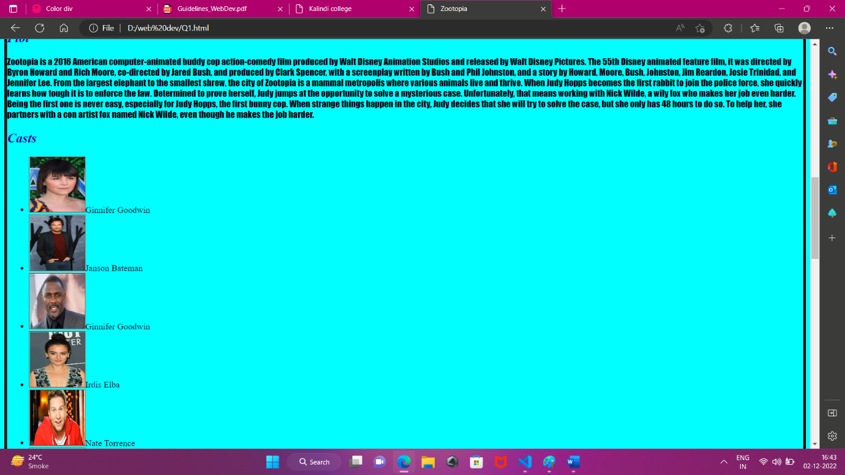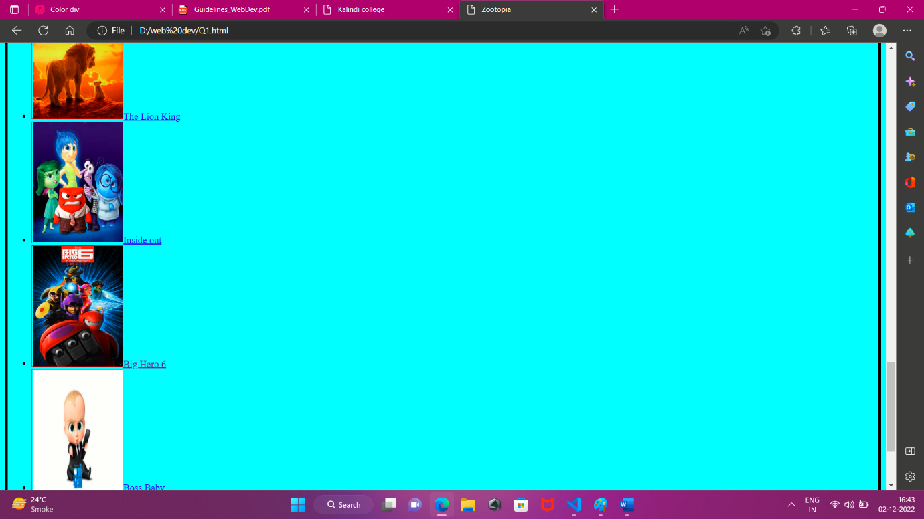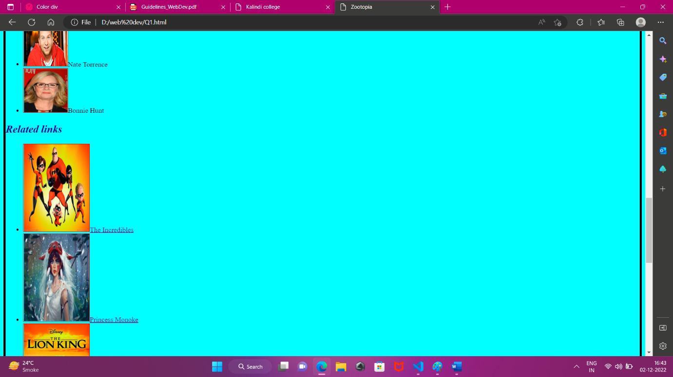

**After clicking on the link bighero 6**

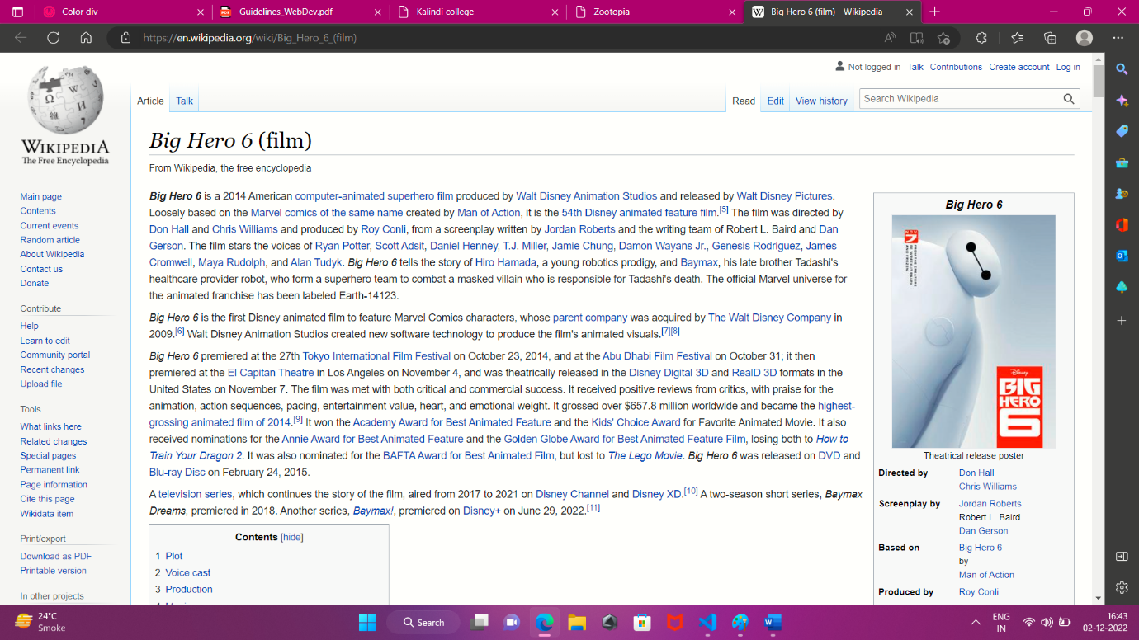

**HTML: Q2)**

**Create an HTML Page to display information about a dummy college in following manner: a. Page must be divided in divisions where the outcome is like Header Navigation Message Notice Gallery Footer b. Header division must contain name and logo of the college. c. Navigation division must display menu or links to various different pages which might store other relevant information. d. Message division must contain image and name of the principal along with the message. e. Notice division must display different notices in an unordered list. f. Gallery division must display images of past events or building of the college. g. Footer division must show contact information of the college.**

**CSS: Q2)**

**Redesign page created in HTML practical 2 such that: a. All divisions have a solid border of 2px. b. Header and Footer division have aquamarine and dark blue background color respectively and same font-style which are larger than all other divisions. c. Background color of the Navigation division should be aqua and links of the pages should appear in UPPERCASE. d. Background color of the message and notices division should be light sky blue and text color should not be black. Message text should be italic and notices should be bold. JavaScript 1. Write JavaScript to validate the form created by student in HTML practical 3 keeping in min**

**Ans) html file**

<html>

    <head><title>Kalindi college</title></head>

    <link rel="stylesheet" href="Q2.css">

    <style>

        .anchor a{

            margin-left:50px;

            color:black;

            text-decoration:none;

            font-size:20px;

        }

        hr{

            height:2px;

            background-color:black;

        }

    </style>

    <body style="border:5px solid black; background-color: rgb(250, 243, 234);">

        <header>

        <div style="display:flex; margin-left:550;margin-right:550px;">

        <img src="https://yoyosarkari.com/wp-content/uploads/2019/08/Kalindi-College-Recruitment-2019.jpg" float="center" width="150" height="150">

        <span>

        <b><h1 style="font-family: Times New Roman; color:rgba(6, 22, 56, 0.77);margin:0px; margin-top:15px; margin-left:10px">Kalindi College</h1></b>

        <h6 style="font-family: Times New Roman; color:rgba(6, 22, 56, 0.77); margin:0px; margin-left:10px;">UNIVERSITY OF DELHI<h6 style="font-family: Times New Roman; color:rgba(6, 22, 56, 0.77); margin:0px; margin-left:10px;">ACCREDITED WITH GRADE 'A' BY NAAC</h6>

        </span>

        </div>

    </header>

        <hr>

        <nav>

        <div style="display:flex;" class="anchor">

            <a href="D:\web dev\header.html" target="_parent" >Home</a>

            <a href="https://www.kalindicollege.in/college-profile/" target="_parent">College profile</a>

            <a href="https://www.kalindicollege.in/code-of-conduct-about/" target="_parent">Code of Conduct</a>

            <a href="https://www.kalindicollege.in/vision-mission/" target="_parent">Vision and Mission</a>

            <a href="https://www.kalindicollege.in/time-table/" target="_parent">Time Table</a><a href="https://www.kalindicollege.in/students-union/">Student Union</a>

            <a href="https://www.kalindicollege.in/alumni/" target="_parent">Alumni</a><a href="https://www.kalindicollege.in/events/">Events</a>

            <a href="https://www.kalindicollege.in/academic-calendar/" target="_parent">Academic Calender</a>

        </div></nav>

        <hr>

        <div style="display:flex;">

        <div style="border:2px solid black; width:50%; height:800px;" class="mess-1">

        <u><b><h1 style="text-align:center;">Principal Desk</h1></b></u>

        <center><img src="https://th.bing.com/th/id/OIP.mgvS8MZN6a7vLH2aIIIVqgHaE8?pid=ImgDet&rs=1" width="300" height="300"></center><br>

        <h2 style=" text-align:center;">Prof. Anula Maurya</h3>

        <p>I want that our students should be imparted an all round education so that they become multidimensional rather than uni-dimensional. In my view, acquiring information is no longer the main focus of education; instead the main aim of education is to build the powers of human mind and spirit. We believe in providing our students an environment, rich in knowledge and supportive for their extra curricular interests.</p>

        <p>We aim to evaluate our students on the basis of their physical, mental, social, emotional and intellectual development. It is wonderful to look back at the last few years, at Kalindi College, when there is so much to feel proud of and so much to celebrate. Last few years have been extremely successful and satisfying in terms of accomplishments and accolades in scholastic, co-scholastic and infrastructural development areas. In Antardhvani-2013, Kalindi College won second prize of Rupees 7 Lakhs as “University Award of Good Practices”. On the year, 2014 college has won third prize of Rupees 5 Lakhs as “University Award of Good Practices” in Antardhvani-2015, a 3-day long academic–cum-cultural festival organized by University of Delhi. The phenomenal academic achievements of our students have always added glory to the college by securing high University Ranks. The college has a tradition of excelling in Sports and extracurricular activities, in which our students continue to bring us laurels at the university, zonal and national levels year after year. The success of Kalindi College in all spheres is the combined product of all our little efforts.</p>

        </div>

        <div style="border:2px solid black; width:50%; height:800px;" class="mess-2">

        <b><u><h1 style=" text-align:center;">Notice Board</h1></u></b>

        <ul type="square">

            <li>Notification regarding Centenary Chance Examination<br><a href="https://www.kalindicollege.in/wp-content/uploads/2022/09/IMG-20220906-WA0005.jpg" target="_parent" >Click Here</a></li>

            <li>Notification regarding inter college migration<br><a href="https://www.kalindicollege.in/wp-content/uploads/2022/08/Document-7.pdf" target="_parent" >Click Here</a></li>

            <li>Hindustan Petrollium Scholarship<br><a href="https://www.kalindicollege.in/wp-content/uploads/2022/08/HPS_notice29082022.pdf" target="_parent" >Click Here</a></li>

            <li>BYPL SASHAKT Scholarship 2022-2023<br><a href="https://www.kalindicollege.in/wp-content/uploads/2022/08/BSES-Scholarship-Poster.pdf" target="_parent" >Click Here</a></li>

            <li>Lecture on "Women in Sports"<br><a href="https://www.kalindicollege.in/wp-content/uploads/2022/08/White-Marble-Certificate-3.pdf" target="_parent" >Click Here</a></li>

            <li>Notice for Budget Estimate, Allocatin and Expenditure committe<br><a href="https://www.kalindicollege.in/wp-content/uploads/2022/08/n12082022.pdf" target="_parent" >Click Here</a></li>

            <li>Invigilation Duty 10 August<br><a href="https://www.kalindicollege.in/wp-content/uploads/2022/08/Invigilation-Duty-10th.pdf" target="_parent" >Click Here</a></li>

            <li>Notice for Flag Hosting<br><a href="https://www.kalindicollege.in/wp-content/uploads/2022/08/CamScanner-08-08-2022-10.56.pdf" target="_parent" >Click Here</a></li>

            <li>Invigilation Duty 8 August<br><a href="https://www.kalindicollege.in/wp-content/uploads/2022/08/DOC-20220807-WA0020..pdf" target="_parent" >Click Here</a></li>

            <li>Invigilation Duty for August-2022 Exam<br><a href="https://www.kalindicollege.in/wp-content/uploads/2022/08/DOC-20220804-WA0003..pdf" target="_parent" >Click Here</a></li>

            <li>Notification regarding implementation of NEP-2020<br><a href="https://www.kalindicollege.in/wp-content/uploads/2022/07/Document-112.pdf" target="_parent" >Click Here</a></li>

            <li>Examination Notice<br><a href="https://www.kalindicollege.in/wp-content/uploads/2022/05/Notification-dt-01.05.22-regarding-Centenary-Chance-registration-01-05-2022.pdf" target="_parent" >Click Here</a></li>

        </ul>

        </div>

    </div>

        <hr>

        <h1 style="color:red; text-align:center;">Gallery</h1>

        <img src="https://th.bing.com/th/id/OIP.A_ia9lMpQRW1p_9pDAjfSgHaDt?pid=ImgDet&rs=1" alt="builiding of kalindi college"><img src="https://th.bing.com/th/id/OIP.9H5h9kKBWMgMPK9kAUBufgHaKe?pid=ImgDet&rs=1" alt="event poster" width="300" height="300"><img src="https://th.bing.com/th/id/OIP.2ttTRheA2xUXhy5k8U4FoAHaCg?pid=ImgDet&rs=1" alt="gallery" height="300" width="500">

        <hr>

        <footer align="center">

        <b><i><h1 style="text-family:arial; color:blue;">Contact Us</h1></i></b>

        <b><h3>Email-Id:</h3></b>

        <p>kalindisampark@kalindi.du.ac.in</p>

        <b><h3>Call at:</h3></b>

        <p>011-25787604</p></footer>

    </body>

</html>

**Css file**

div{

    border: 2px solid;

}

header{

    background-color: aquamarine;

    font-size: 20px;

}

footer{

    background-color: darkblue;

    font-size: 20px;

}

nav{

    background-color: aqua;

    text-transform: uppercase;

}

.mess-1,.mess-2{

    background-color: lightblue;

    color:green;

}

.mess-1{

    font-style: italic;

}

.mess-2{

    font-weight: bold;

}

**Output**

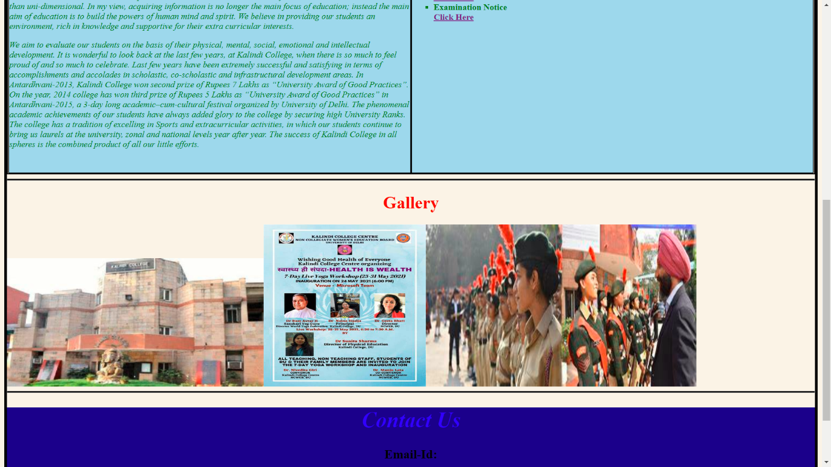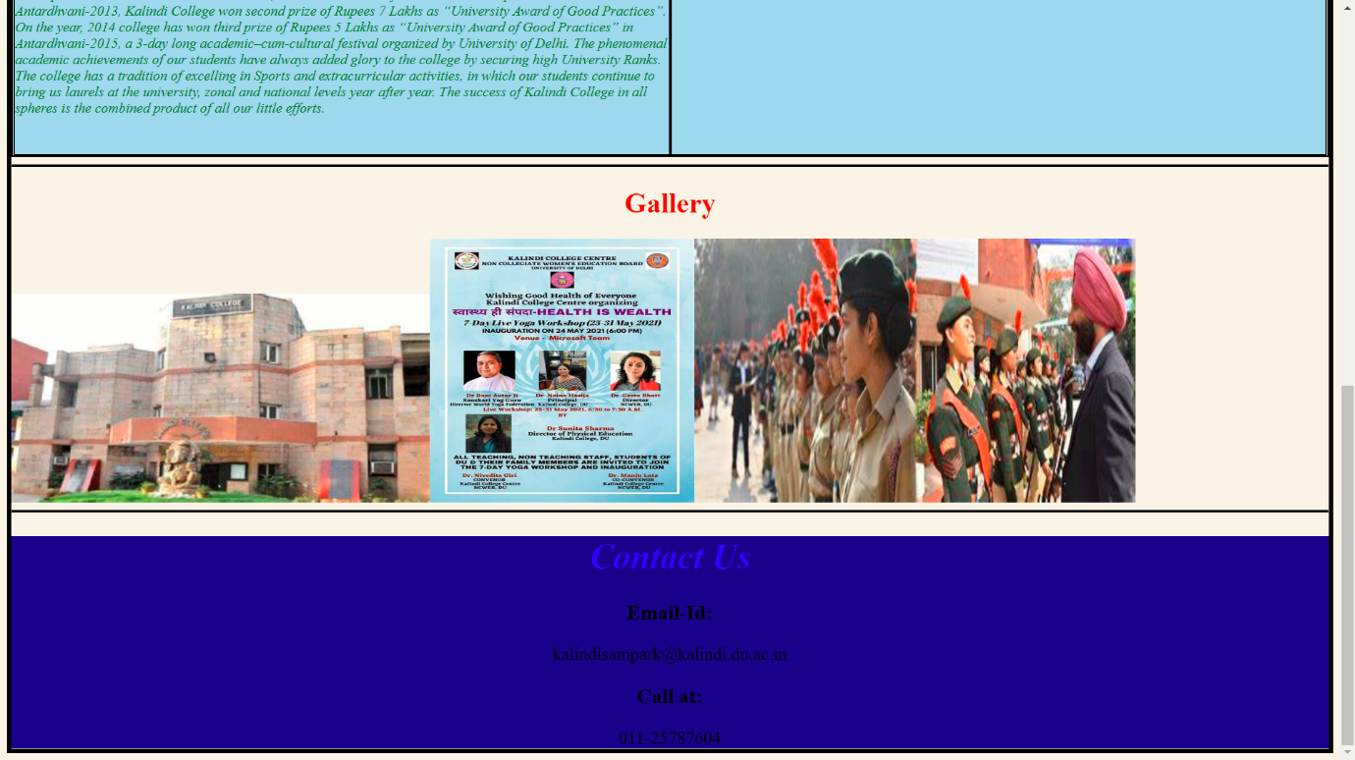

**HTML: Q3)**

**Create an HTML Page showing the form asking information in following format: a. Name of the student as text. b. Roll no. of the student as text. c. Email of the student as text. d. Age of the student as number. e. Gender of the student using radio buttons. f. Societies he/she opted for using check boxes. g. Name of the course from a drop down list. h. Address of the student in a text area. i. Photo as file. j. Submit button to submit this data to report.php page using get method.**

**Ans)**

<html>

<head>

<title>Students Details</title>

<link rel="stylesheet" href="Q3.css">

</head>

<body style="background-color:black;">

<div style="background-color:rgb(250, 243, 234);padding-right:30; height:700px; width:600px;  margin-top:30; margin-left:400; border:3px solid red;">

    <h1 style="text-align:center; color:blue;"><u>STUDENT FORM</u></h1>

    <form name= "myform" style="margin-left:20;">

        <br><br><label for="name"><b>Name:</b><input type="text" id="name" name="Name" size="15" style="margin-left:100;"><br>

        <label for="rno"><b>Roll-no:</b><input type="text" id="rno" name="Rno" size="8" style="margin-left:90;"><br>

        <label for="email"><b>Email-ID:</b><input type="email" id="email" name="email" style="margin-left:78;"><br>

        <label for="age"><b>Age:</b><input type="number" id="age" name="Age" size="2" style="margin-left:115;"><br>

        <label for="gen"><b>Gender:</b><input type="radio" id="gen" name ="Gender" value="female" style="margin-left:90;">Female<input type="radio" id="gen" name="Gender" value="male">Male<input type="radio" id="gen" name="gender" value="other">Other<br>

        <label for="society"><b>Society Joined:</b><br><input type="checkbox" name="KalPdhra" id="society" value="KalPdhra">KalPdhra<br>

        <input type="checkbox" name="Society" id="society" value="Satvva">Satvva<br>

        <input type="checkbox" name="Society" id="society" value="Nupur">Nupur<br>

        <input type="checkbox" name="Society" id="society" value="aghaz">Aghaz<br>

        <input type="checkbox" name="Society" id="society" value="raqs">Raqs<br>

        <input type="checkbox" name="Society" id="society" value="arogya">Arogya<br>

        <h4>Name of Course:</h4>

        <select name="dropdown">

            <option value="bsc">Bsc(Graduation)</option>

            <option value="ba">BA(Graduation)</option>

            <option value="bcom">Bcom.(Graduation)</option>

            <option value="bscprgm">Bsc Programme</option>

            <option value="bcmprgm">Bcom Programme</option>

            <option value="baprgm">Ba Programme</option>

            <option value="bscH">Bsc(H) Hons.</option>

            <option value="bcomH">Bcom(H) Hons.</option>

            <option value="baH">Ba(H) Hons.</option>

            <option value="other">Others</option>

        </select><br><br>

        <label for="adds"><b>Address:</b><input type="text" id="adds" name="Adderess" value="Ramnagar Dilshad Garden Delhi" size="50" style="margin-left:90;"><br>

        <h4>Pass-Port Size Photo</h4>

        <input type="file" value="file" name="file"><br><br>

        <input type="submit" style="width:100px; height:40px; font-size:20px; background-color:red; color:white;" onclick="validation()">

    </form>

    </div>

</body>

</html>

Css file

div{

    border: 2px solid;

}

header{

    background-color: aquamarine;

    font-size: 20px;

}

footer{

    background-color: darkblue;

    font-size: 20px;

}

nav{

    background-color: aqua;

    text-transform: uppercase;

}

.mess-1,.mess-2{

    background-color: lightblue;

    color:green;

}

.mess-1{

    font-style: italic;

}

.mess-2{

    font-weight: bold;

}

**OUTPUT**

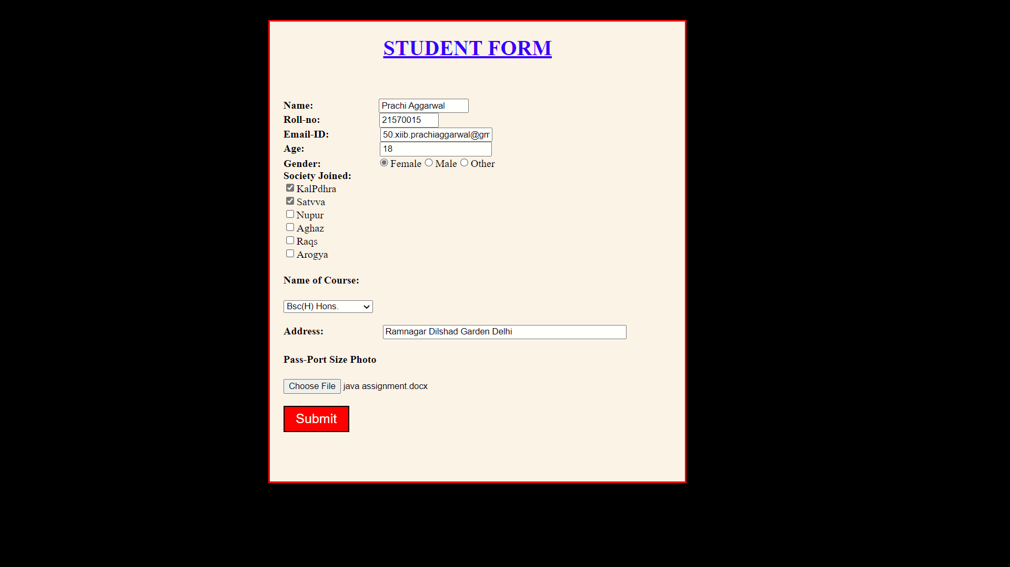

**Java Script**

**Q1) Write JavaScript to validate the form created by student in HTML practical 3 keeping in mind following constraints: a. No text box or text area should be left blank. b. Validate whether the Roll no. and Email of the student are in proper format. c. Age must be in the range 16-22. d. Photo must be a file of type jpg/jpeg/png. e. Data will be sent to report.php page only if all these constraints are fulfilled otherwise display corresponding errors.**

**Ans) script part of html q3.html**

<script>

    function validation() {

        var name = document.myform.Name.value;

        var roll = document.myform.Rno.value;

        var age = document.myform.Age.value;

        var filePath = document.myform.file.value;

        var allowedExtensions =/(\.jpg|\.jpeg|\.png|\.gif)$/i;

        if (!allowedExtensions.exec(filePath)) {

            alert('Invalid file type');

            fileInput.value = '';

            return false;

        }

        if (name == null || name == "") {

            alert("Name cannot be blank");

            return false;

        }  if (roll.length != 8) {

            alert("Wrong rollno");

            return false;

        }  if (age < 16 || age > 22) {

            alert("invalid age");

            return false;

        }

    }

</script>

**OUTPUT**

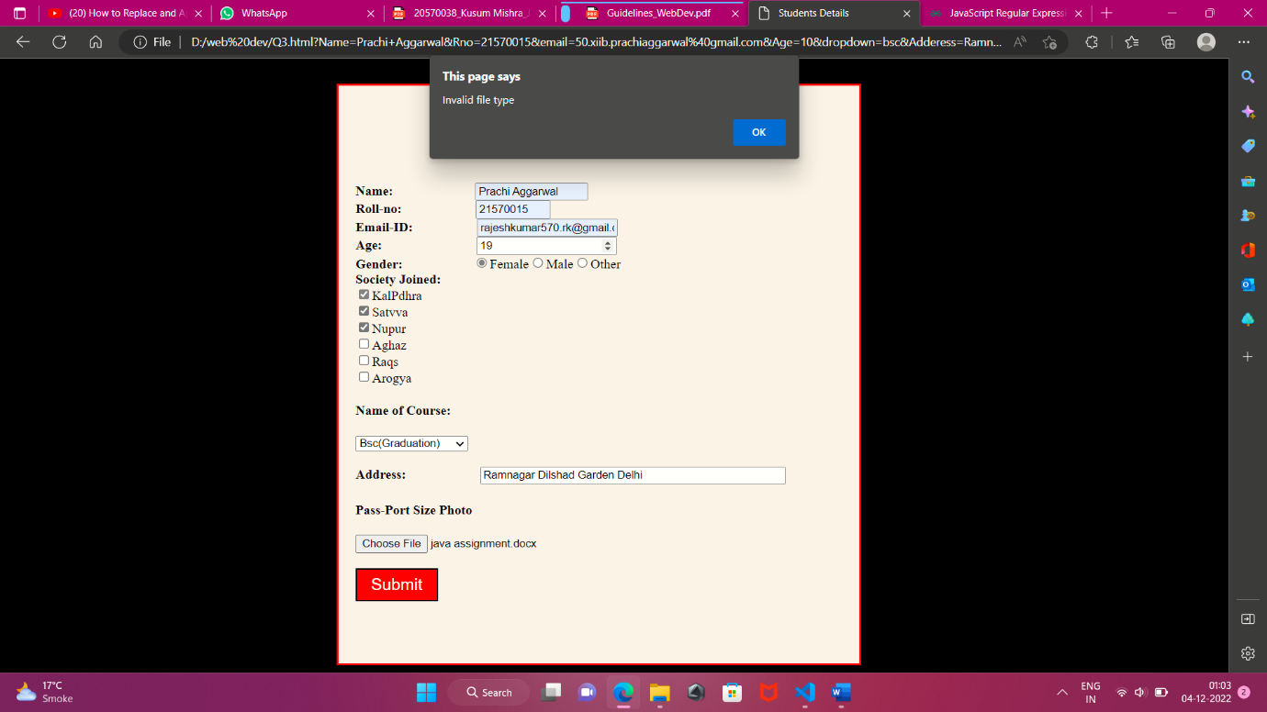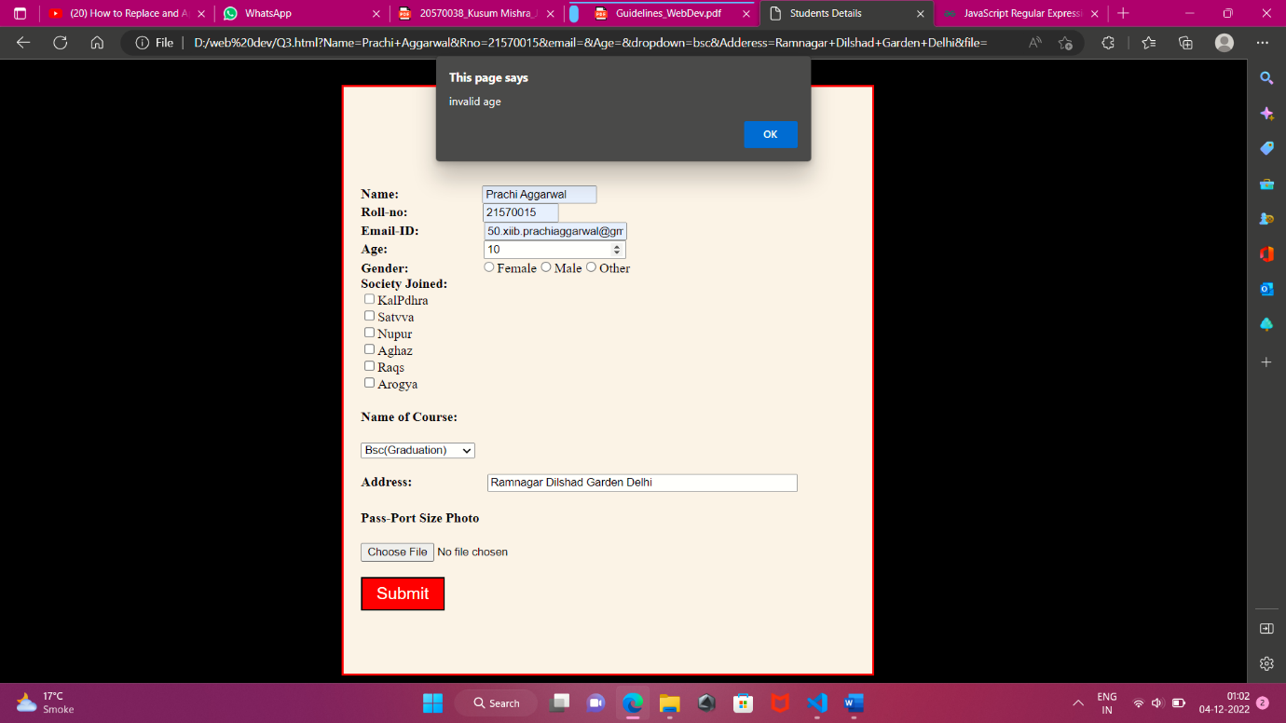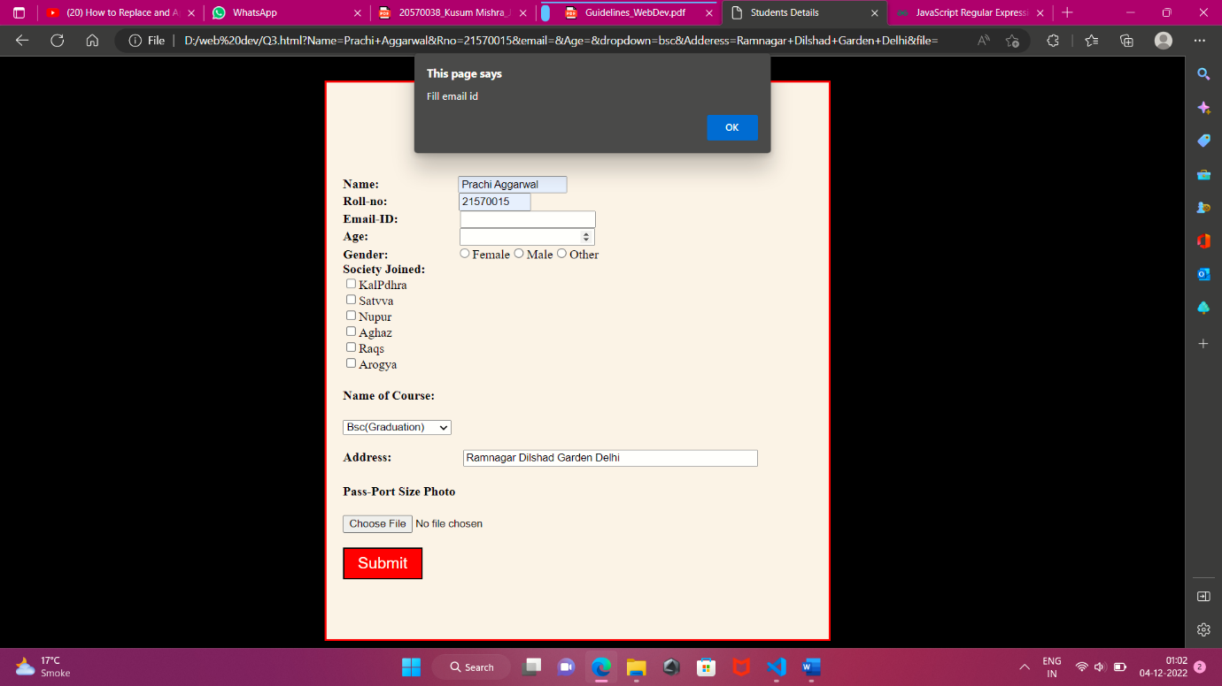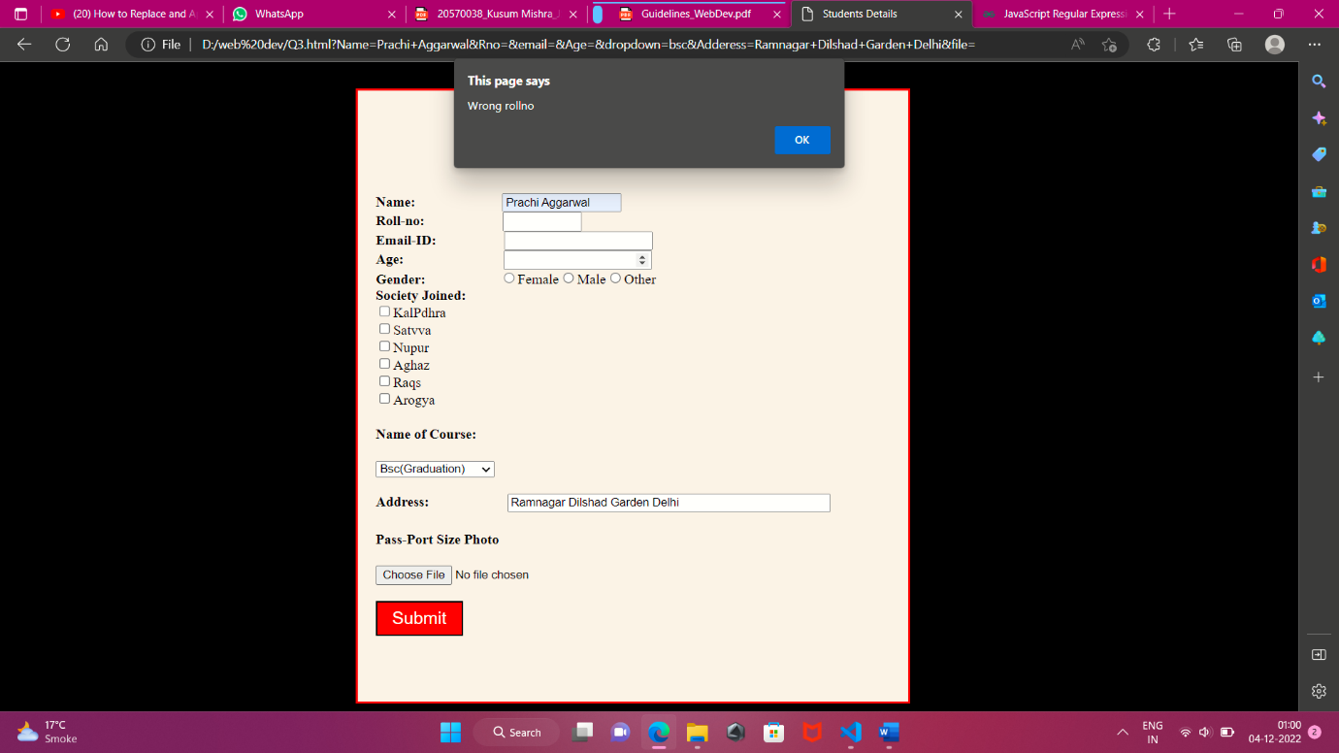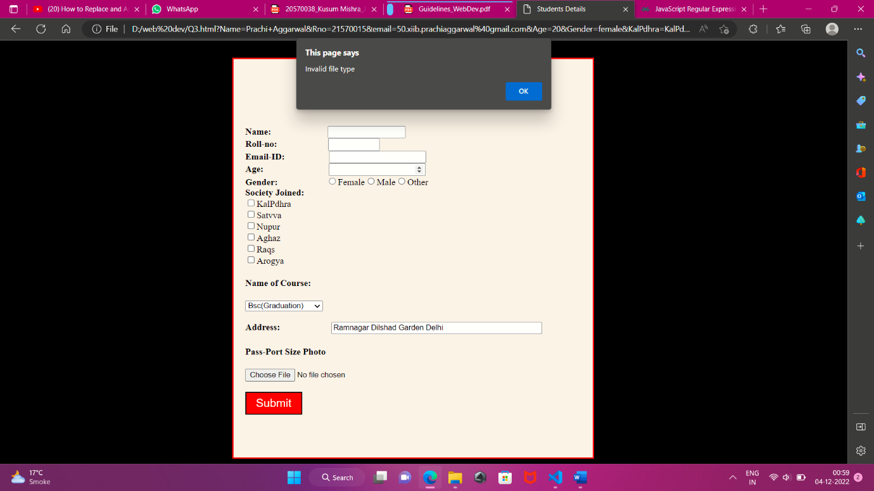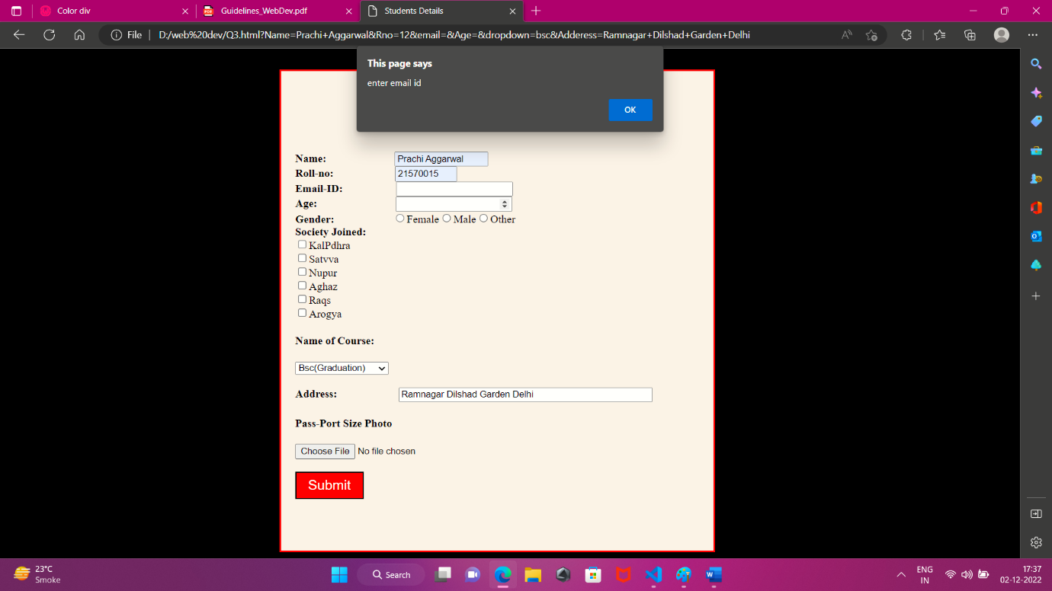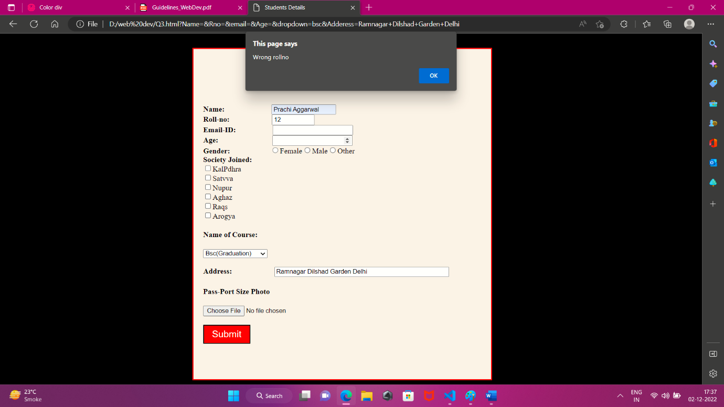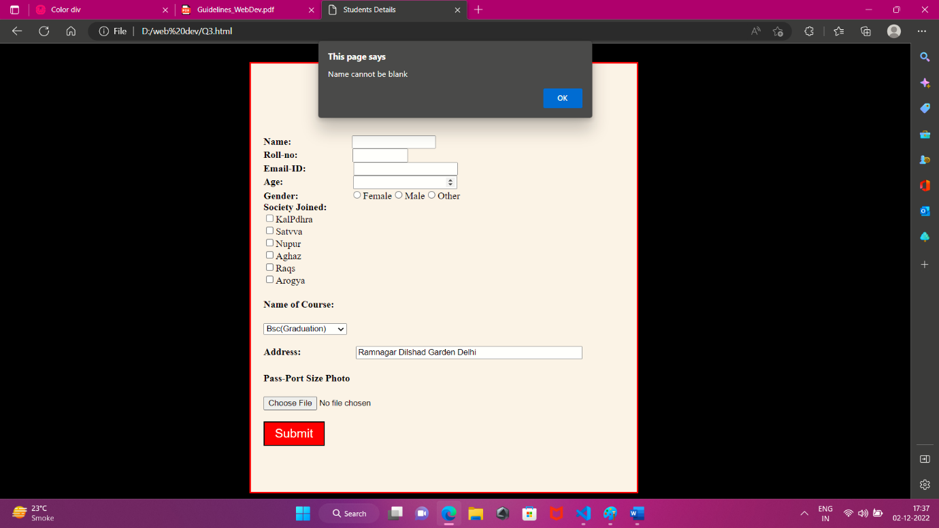

**Q2) Write JavaScript to show the usage of setInterval function using which background color of a division keeps on changing to a random color every 2 seconds. Also use setTimeout function to show the content of a textbox as label of large size after 3 seconds.**

**ANS)**

<html>

    <head>

        <title>

            change

        </title>

    </head>

    <body>

        <h1>This is a Text Box</h1>

        <input type="text" id="demo" width="100px" height="50px">

        <button type="button" onclick="change()" style="background-color:red; color:white; width:100px; height:40px;">Start</button>

    </body>

    <script>

        function change(){

            setTimeout(bigger,3000);

            setInterval(colour,2000);

        }

        function bigger(){

            document.getElementById("demo").style.fontSize="150px";

        }

        var i=0;

        function colour(){

            var col = new Array("Red","Blue","Yellow","Green");

            document.body.style.backgroundColor=col[i];

            i = (i+1)%col.length;

        }

    </script>

</html>

**OUTPUT**

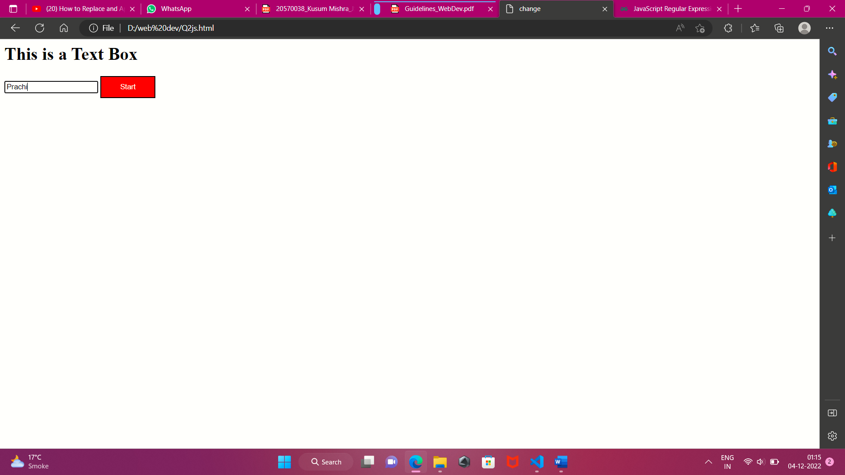

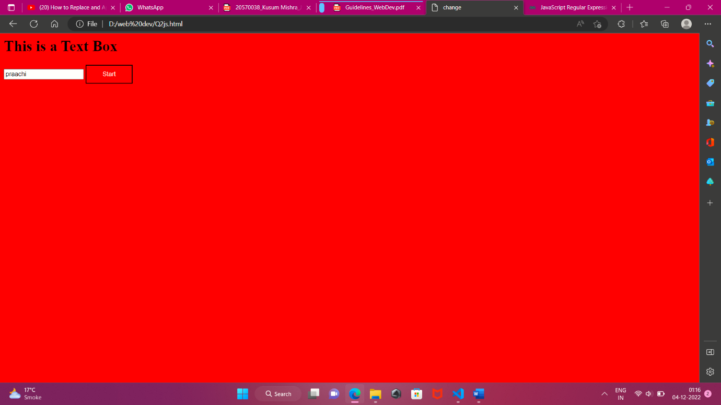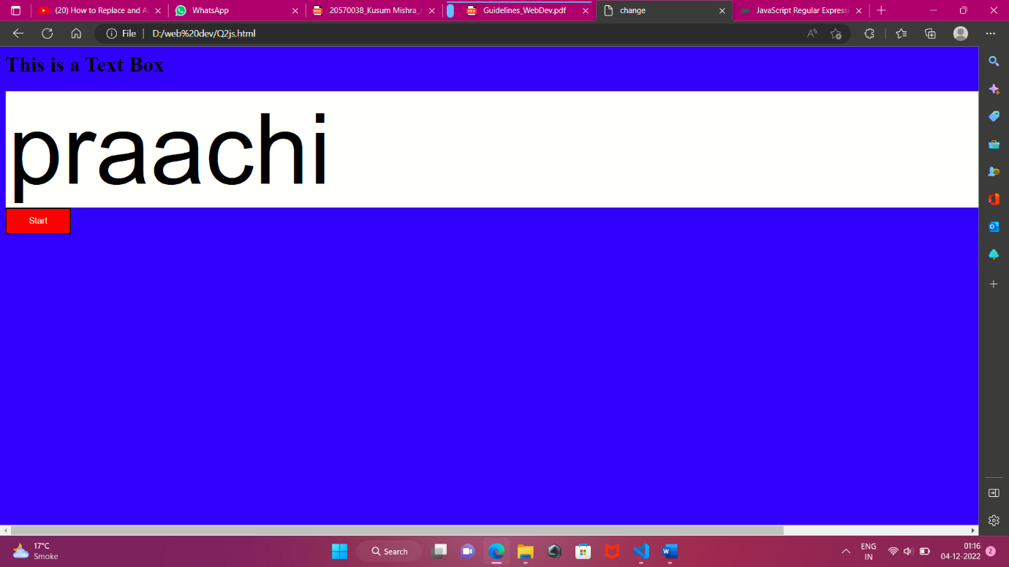

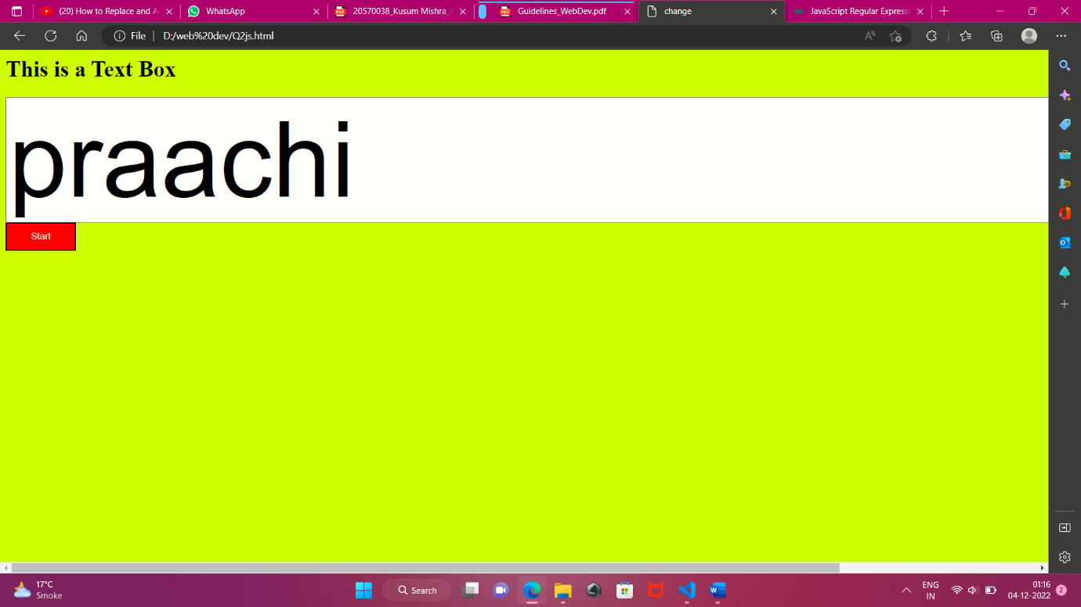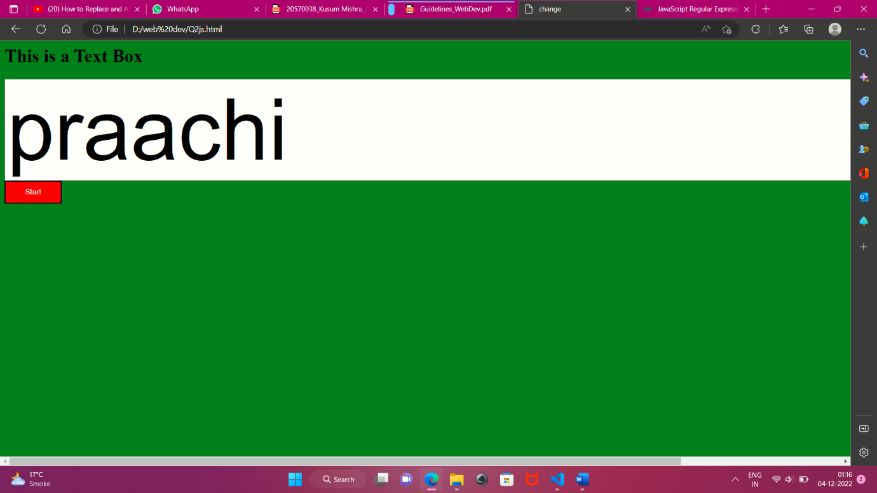

**Q3)** **Prompt user to enter his name and add it to cookies. If the user is new user then show an alert box stating Welcome otherwise display Welcome again . Cookies should get removed already after 24 hours.**

**ANS)**

<html>

<head>

    <title>JS Q3</title>

    <script>

        function setCookie(cname, cvalue, exdays) {

            var d = new Date();

            d.setTime(d.getTime() + (24 * 60 * 60 * 1000));

            var expires = "; expires=" + d.toUTCString();

            document.cookie = cname + "=" + cvalue + ";" + expires + ";path=/";

            alert("Welcome " + cvalue + "!");

        }

        function getCookie(cname) {

            var name = cname + "=";

            var decodedCookie =decodeURIComponent(document.cookie);

            var ca = decodedCookie.split(';');

            for (var i = 0; i < ca.length; i++) {

                var c = ca[i];

                while (c.charAt(0) == ' ') {

                    c = c.substring(1);

                }

                if (c.indexOf(name) == 0) {

                    return c.substring(name.length, c.length);

                }

            }

            return "";

        }

        function checkCookie() {

            var user = getCookie("username");

            if (user != "") {

                alert("Welcome again " + user + "!");

            }

            else {

                user = prompt("Enter your name:", ""); if (user != "" && user != null) {

                    setCookie("username", user, 24);

                }

            }

        }

    </script>

</head>

<body onload="checkCookie()"></body>

</html>

**OUTPUT**

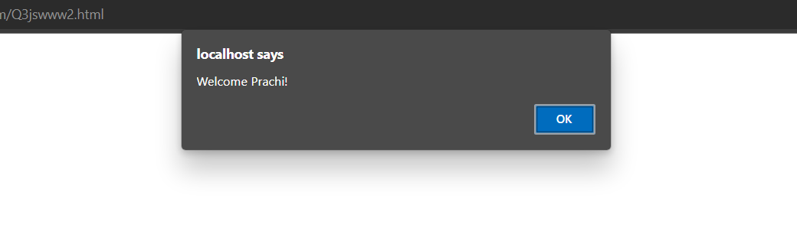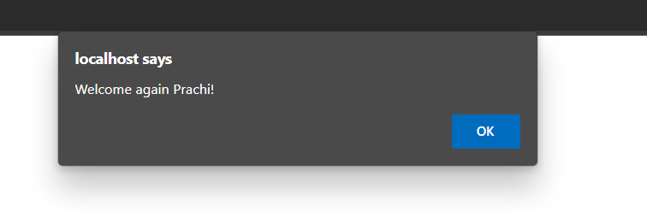

**PHP Programs**

**Q1)** **Write PHP script to construct the following pattern using nested for loop.**

**\* * * * * * \***

**\* * * * * \***

**\* * * \***

**\* \***

**\* * * \***

**\* * * * * \***

**\* * * * * * * \***

**Ans)**

<?php

    $n=5;

    for($i=0; $i<$n; $i++){

        for($j=0; $j<$n;$j++){

            if($i+$j >= $n){

                echo "&nbsp&nbsp";

            }

            else{

                echo "*";

            }

        }

        for($j=0; $j<$n; $j++){

            if($i>$j){

                echo "&nbsp&nbsp";

            }

            else{

                echo "*";

            }

        }

        echo "<br>";

    }

    for($i=0; $i<$n; $i++){

        for($j=0; $j<$n; $j++){

            if($i>=$j){

                echo "*";

            }

            else{

                echo "&nbsp&nbsp";

            }

        }

        for($j=0; $j<$n; $j++){

            if($i+$j>=$n-1){

                echo "*";

            }

            else{

                echo "&nbsp&nbsp";

            }

        }

        echo "<br>";

    }

?>

**OUTPUT**

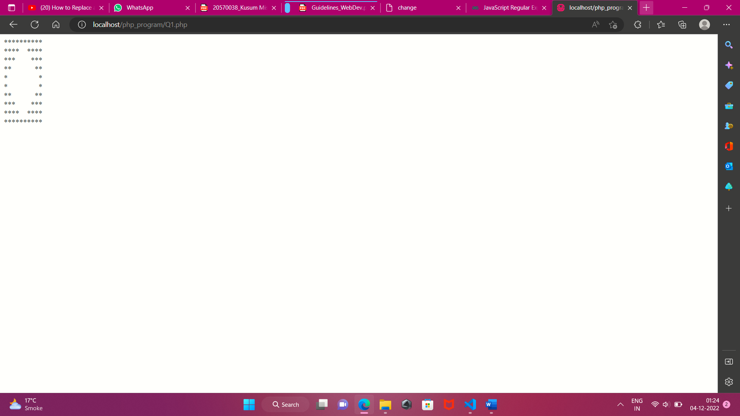

**Q2)** **Accept a number from an HTML page and send it to a PHP file. Validate that this number is a positive integer in the range 2-100. PHP file should check whether this number is prime or composite. If number is found prime then Fibonacci series till that element is also printed otherwise factorial of that number is to be printed.**

**Ans)**

**Html file**

<html>

    <head>

        <title>Check Number</title>

    </head>

    <script>

        function validation(){

            var valid = document.myform.box.value;

            if(valid==""){

              alert("Enter a number");

            }

            else if(valid>100 || valid<2){

                alert("Enter the valid number range between 2 and 100");

            }

        }

    </script>

    <body>

        <form name = "myform" method="get" action="Q2.php">

            <label for="accept">Enter the number:</label><br>

            <input type="text" id="accept" name="box"><br><br>

            <input type="submit" value="Result" onclick="validation()" style="background-color:red; color:white;">

        </form>

    </body>

</html>

**Php file**

<?php

    $value = $_REQUEST['box'];

    echo "Value is: ".$value."<br>";

    $flag = 0;

    for($i=2; $i<=($value/2); $i++){

        if($value%$i==0){

            $flag=1;

            break;

        }

    }

    if($flag==1){

        echo "The fibonnacci series till limit ".$value." is:"."<br>";

        $x=0;

        $y=1;

        $sum=0;

        echo $x."&nbsp".$y."&nbsp";

        for($i=0; $i<$value-2; $i++){

            $sum = $x+$y;

            $x=$y;

            $y=$sum;

            echo $sum."&nbsp";

        }

    }

    else{

        $fact=1;

        for($i=1; $i<=$value; $i++){

            $fact = $fact*$i;

        }

        echo "The factorial of the number is: "."<br>";

        echo $fact;

    }

?>

**OUTPUT**

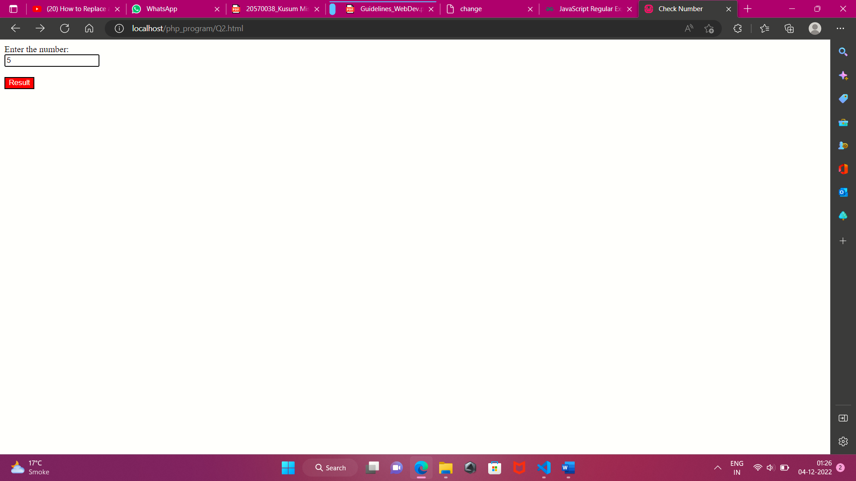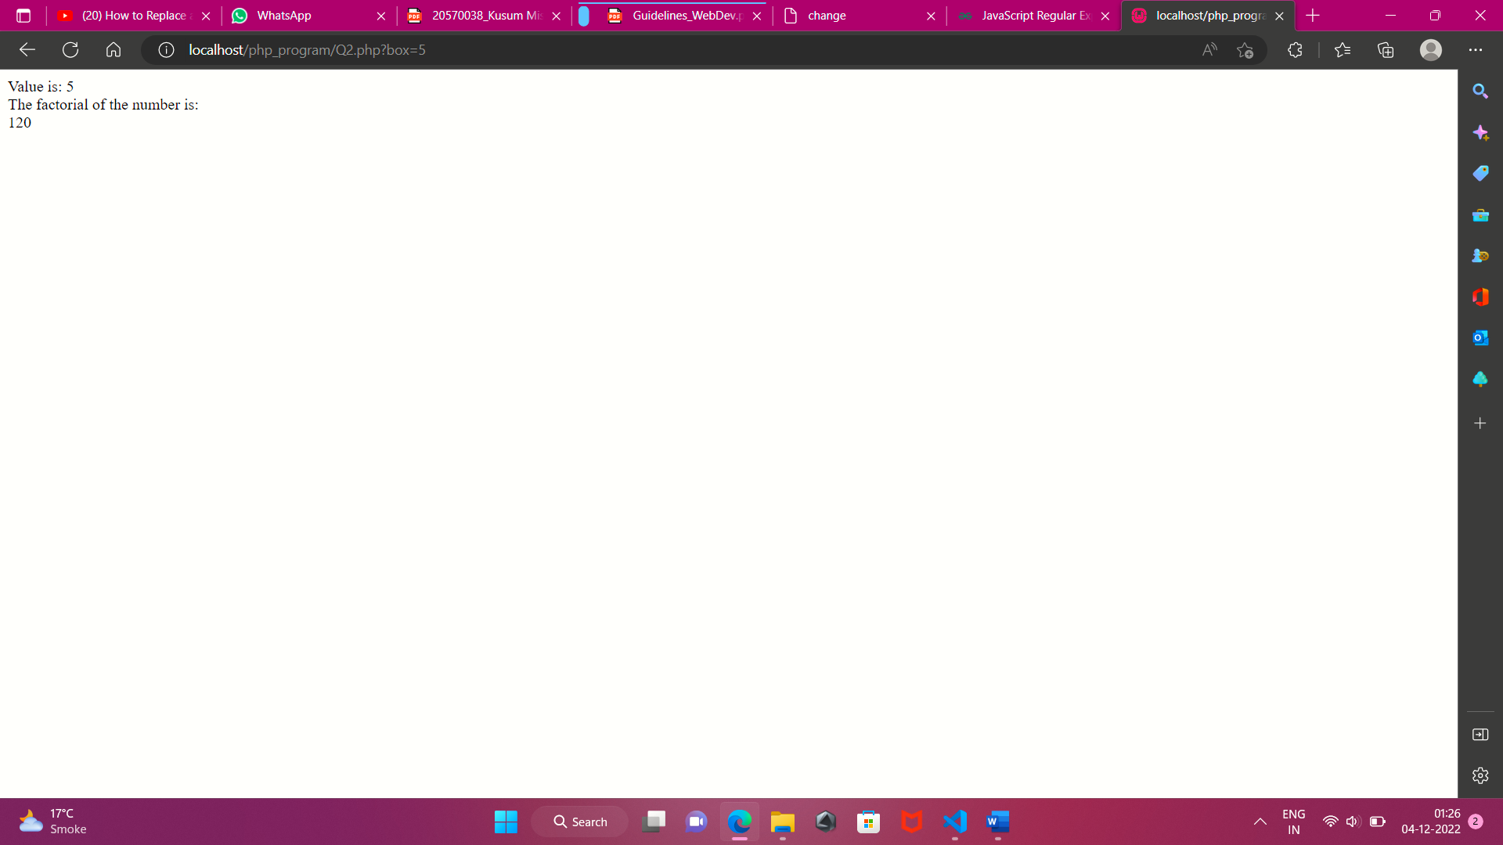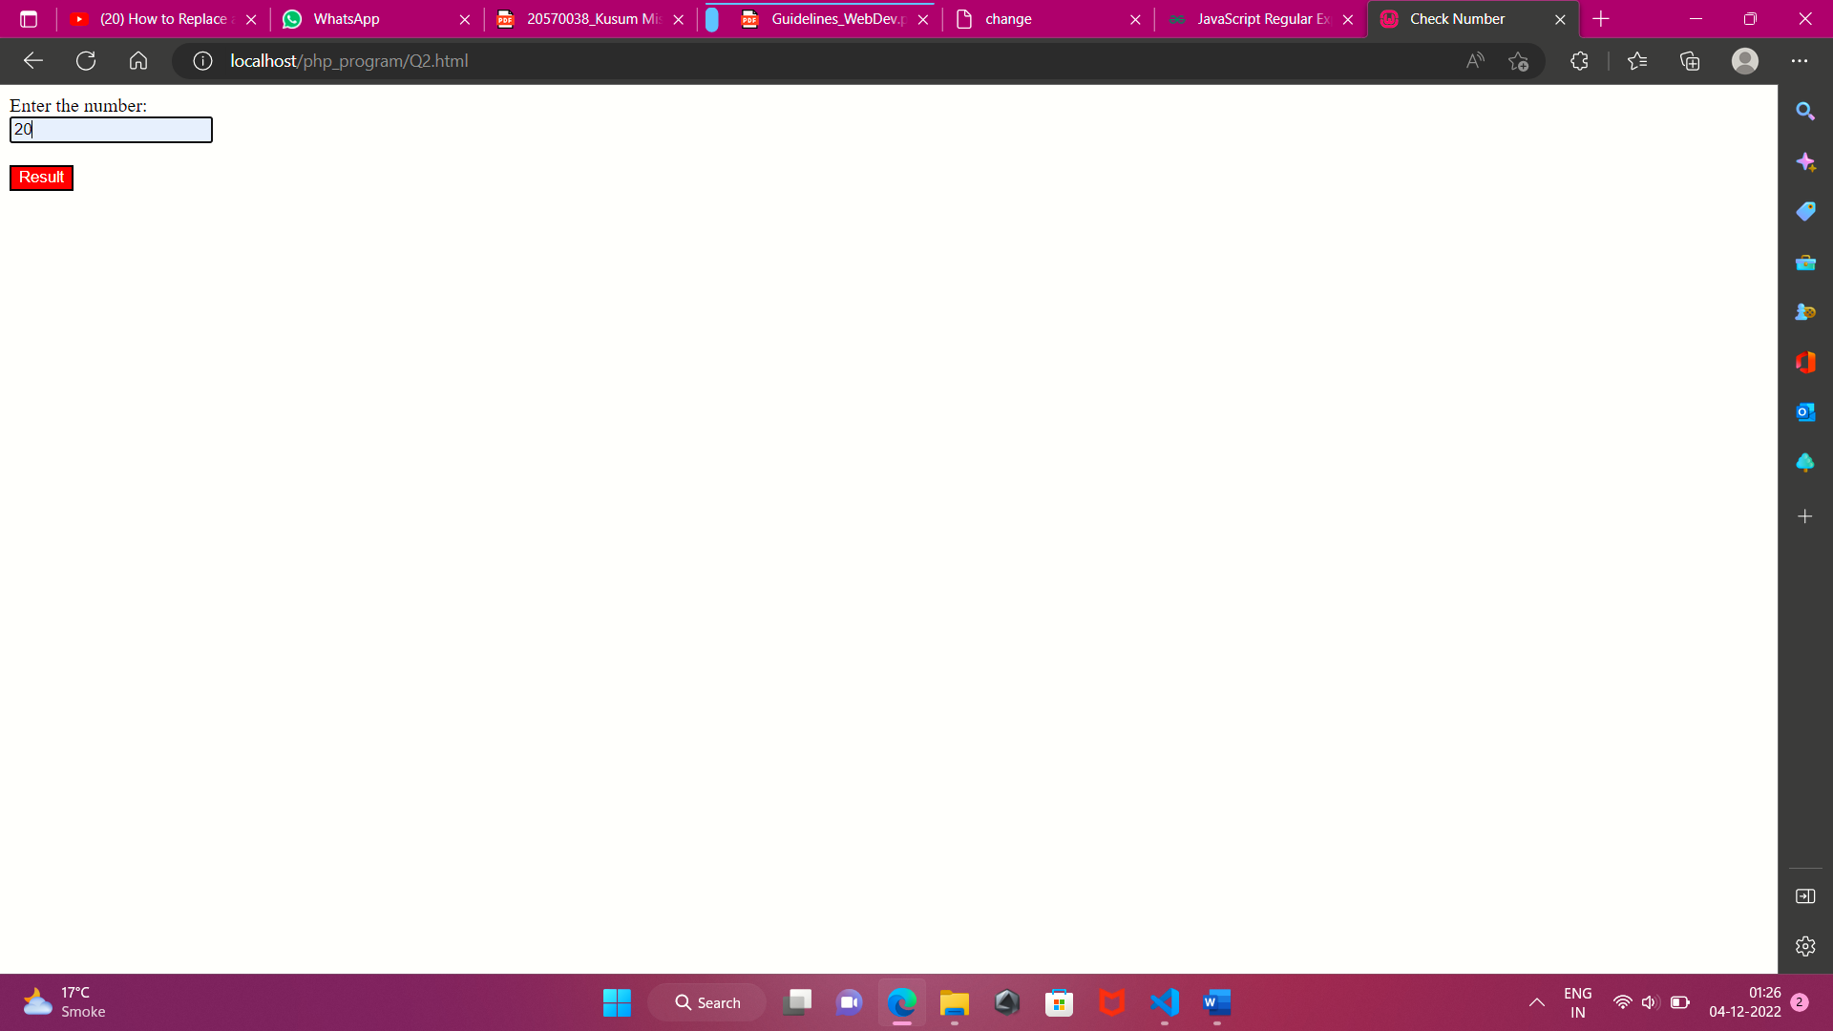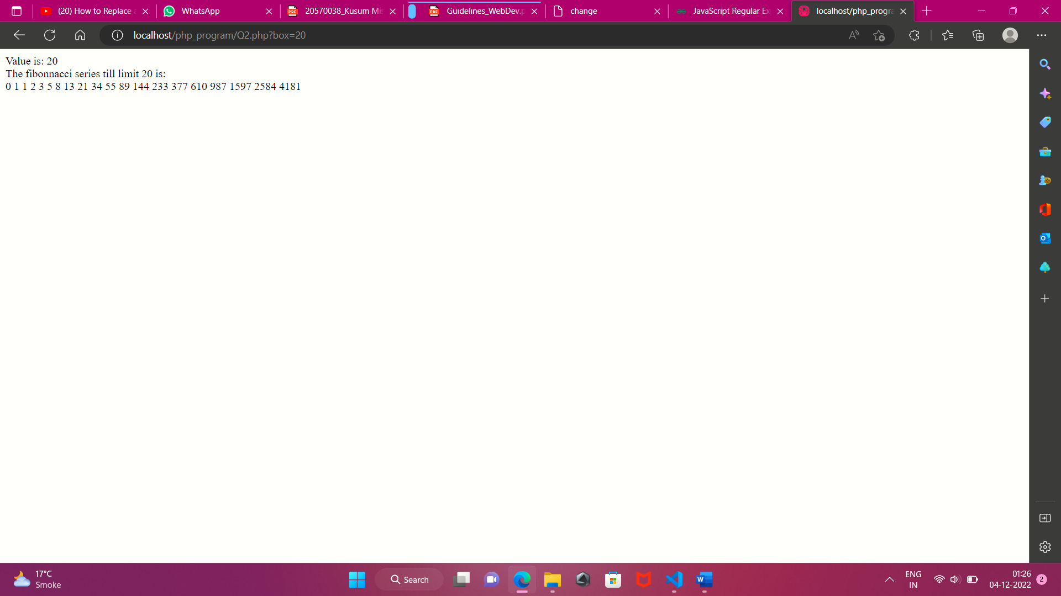

**Q3)** **Write a PHP file colors.php which declares an array of ten colors names. Every time this file is accessed a random color from this array should be chosen and same is to be set as the background color of a division.**

**Ans)**

<html>

    <head>

        <title>

            Color div

        </title>

    </head>

    <body>

            <?php

                $colours = ['Red','Blue','Green','Yellow','Orange','Brown','Black','Cyan','Pink','DarkMagenta','MediumPurple'];

                $random_color = array_rand($colours,1);

            ?>

            <div style="background-color:<?php echo $colours[$random_color]?>; margin-top:200px; margin-left:40%;border:2px solid black;width:200px; height:200px;">

                Prachi

                </div><br>

    </body>

</html>

**OUTPUT**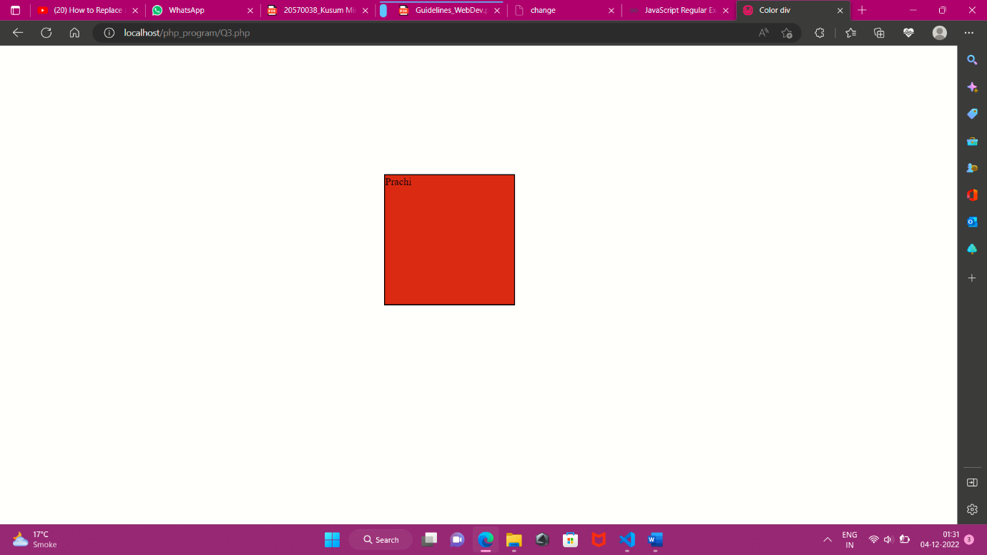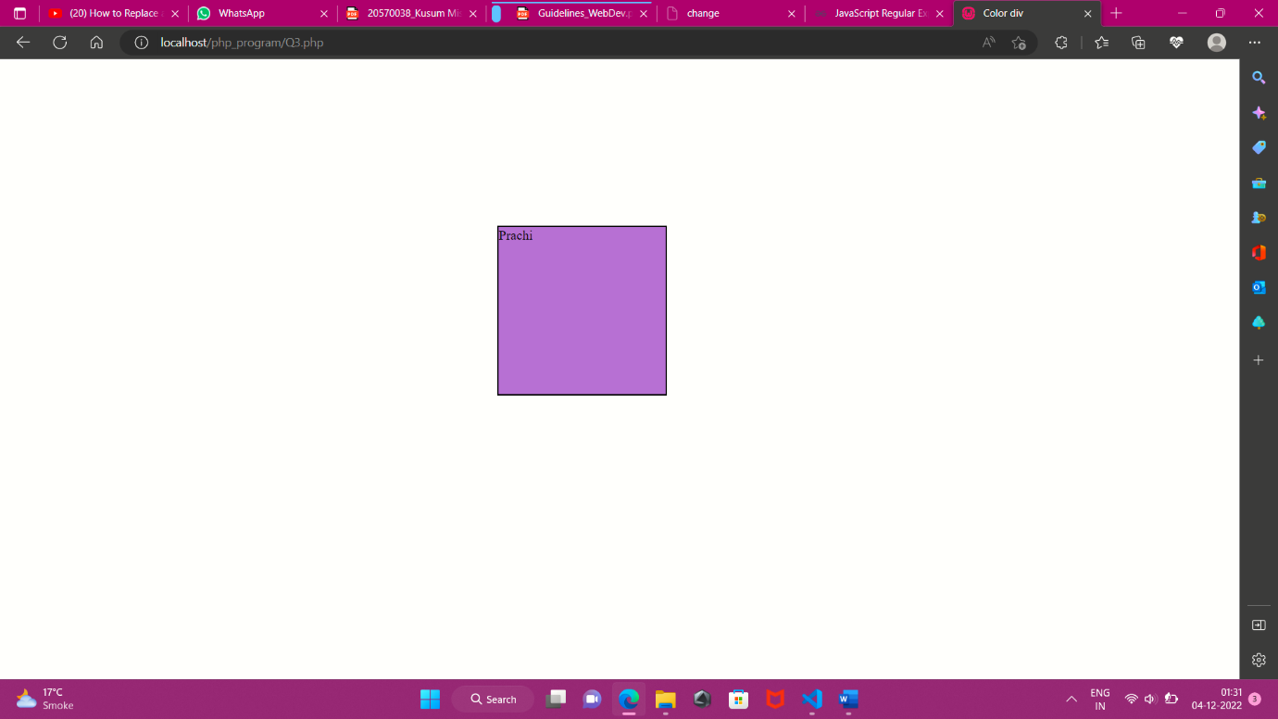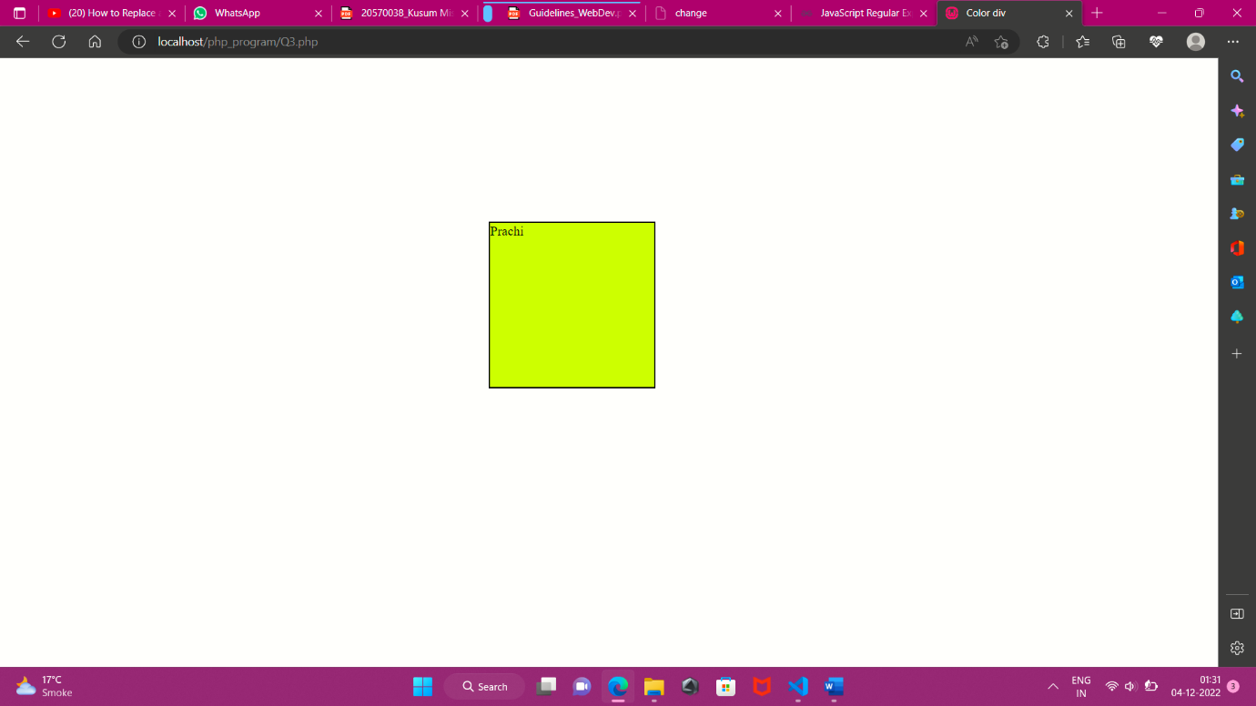 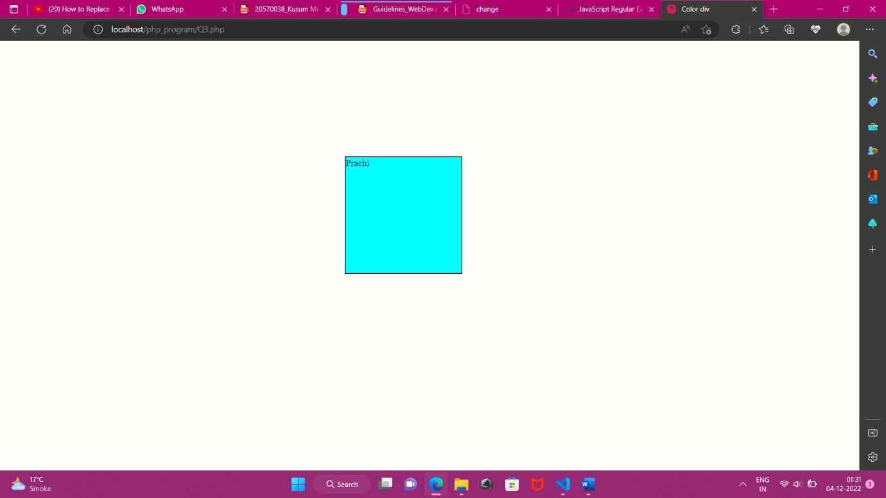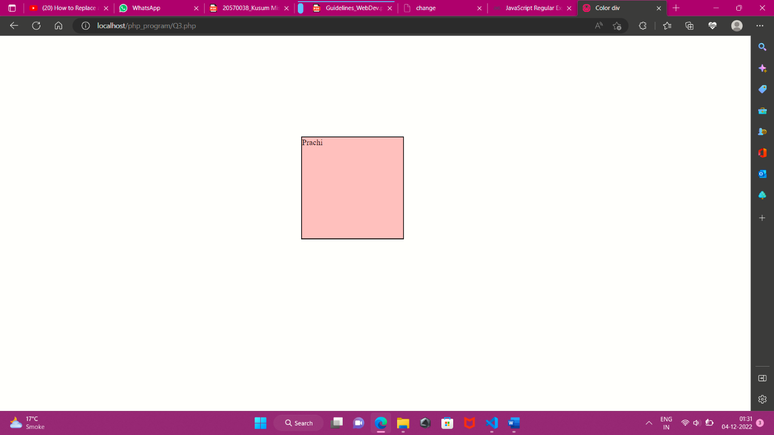

**Q4)** **Create a login page asking for user name and password from. On submitting these details, a welcome message should be displayed if the user already exists in the database. Otherwise an error message is to be displayed.**

**ANS)**

<html>

<head>

 <title> LOGIN FORM</title>

 <link rel="stylesheet" type="text/css" href="style.css">

</head>

<body id="body_bg">

<div align="center">

<h3> LOGIN FORM</h3>

<form >

 <table border="0.5" >

<tr>

    <td><label for="ID">UserId</label></td>

    <td><input type="text" name="ID" id="ID" > </td>

</tr>

 <tr>

 <td><label for="user_id">User Name</label></td>

 <td><input type="text" name="user_id" id="user_id"></td>

 </tr>

 <tr>

 <td><label for="user_pass">Password</label></td>

 <td><input type="password" name="user_pass"

id="user_pass"></input></td>

 </tr>

 <tr>

 <td><input type="submit" value="Submit" />

 <td><input type="reset" value="Reset"/>

 </tr>

 </table>

</form>

</div>

<?php

$username;$userid;$password;

 $connection = mysqli_connect('localhost', 'root', '','prachi');

 if($connection==false){

    die("not connect");

}

 if (isset($_REQUEST['user_id']) && isset($_REQUEST['ID']) && isset($_REQUEST['user_pass']))

 {

 // Assigning POST values to variables.

$userid= $_REQUEST['ID'];

$username = $_REQUEST['user_id'];

$password = $_REQUEST['user_pass'];

 // CHECK FOR THE RECORD FROM TABLE

}

else{

    die("something wrong");

}

$query = "SELECT * FROM login";

$result = mysqli_query($connection,$query);

if($result==false){

   die("query failed");

}

while($row=mysqli_fetch_array($result)){

    if($row['User Name']!= $_REQUEST['user_id'] || $row['ID']!=$userid || $row['Password']!=$password){

        die("Wrong credentials");

    }

    else{

        echo "Welcome user";

    }

}

?>

</body>

</html>

**OUTPUT**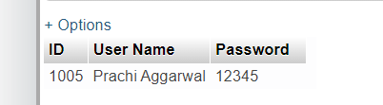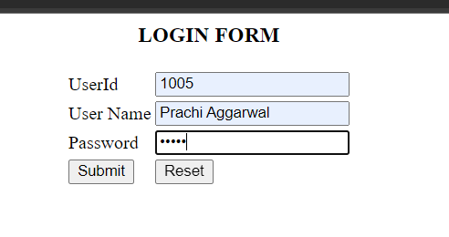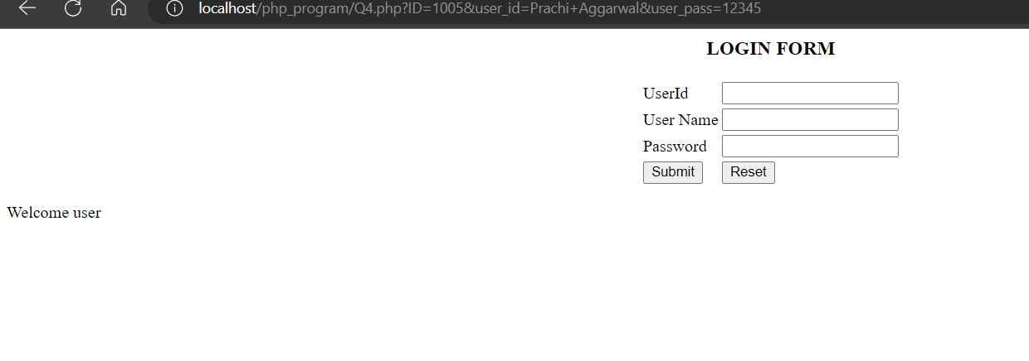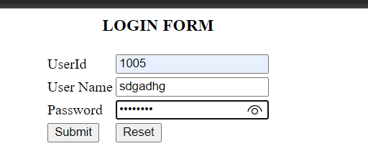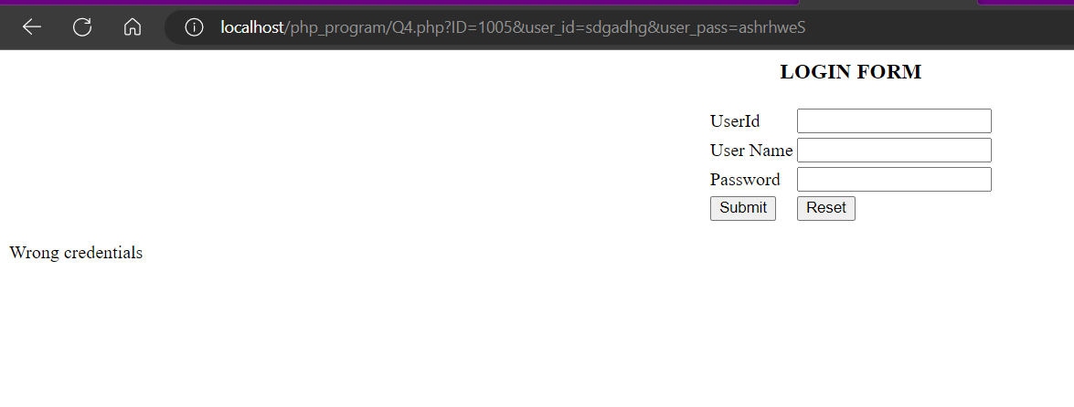

**Q5)** **Create a table student_details in MySql which is capable of storing the information which is being passed in HTML practical 3. Write PHP code in a file named report.php which validates all the data and then stores it in table and displays the same. After insertion of the entries in the database, an alert box should be displayed stating whether the insertion was successful or not.**

**Ans)**

<?php

$username;$userid;$password;

 $connection = mysqli_connect('localhost', 'root', '','prachi');

 if($connection==false){

    die("not connect");

}

$name = $_REQUEST['Name'];

$rollno= $_REQUEST['Rno'];

$email= $_REQUEST['email'];

$age= $_REQUEST['Age'];

if(isset($name) || isset($rollno) || isset($email) || isset($age)){

    $query = "INSERT INTO `student_details` (`Name`, `Rollno`, `Age`, `Email ID`) VALUES('$name', '$rollno', '$age', , '$email');";

    $result = mysqli_query($connection,$query);

    echo "<script>alert('Succesfully insertee')</script>";

}

?>

**Output**

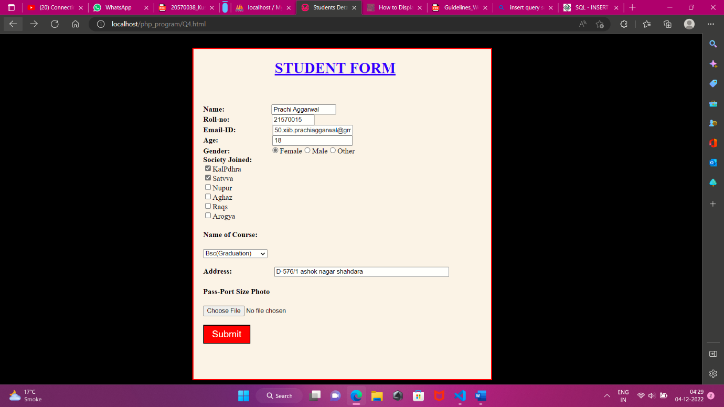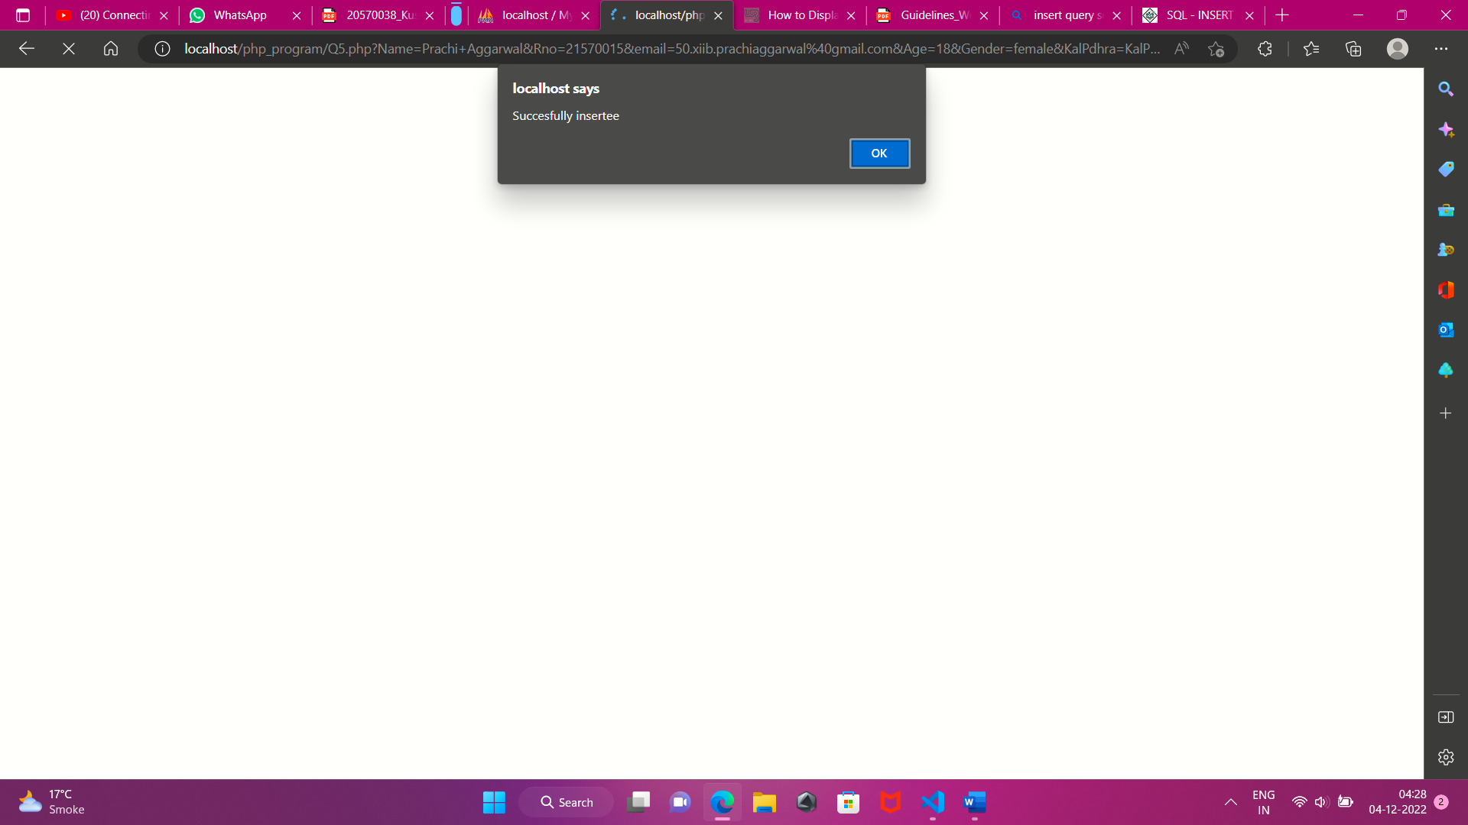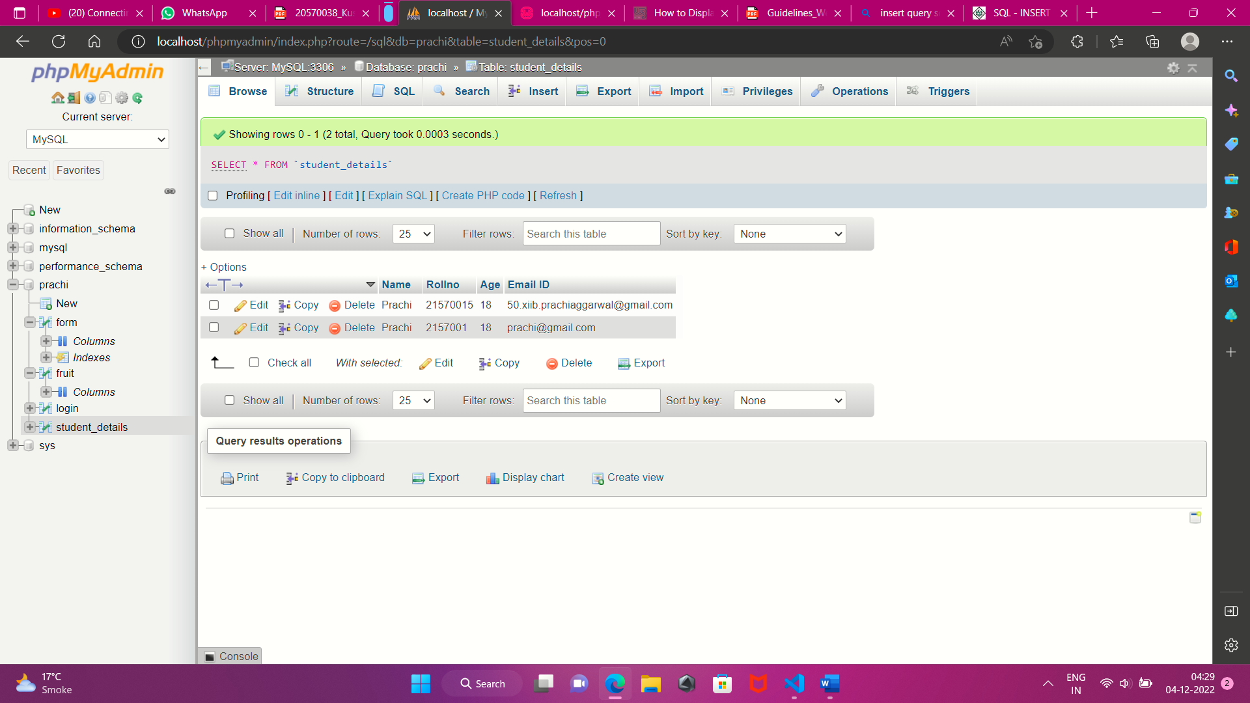

**Q6) Write PHP code in a file named db.php which fetches the data from student_details table and displays the data in tabular way.**

**Ans)**

<?php

$username;$userid;$password;

 $connection = mysqli_connect('localhost', 'root', '','prachi');

 if($connection==false){

    die("not connect");

}    $query2 = "SELECT * FROM student_details";

    $result2=mysqli_query($connection,$query2);

    echo "<script>alert('Succesfully insertee')</script>";

    while($row=mysqli_fetch_array($result2)){

        echo "<table border='1'>";

        echo "<tr>";

        echo "<th>Name</th><th>Rollno</th><th>Age</th><th>EmailId</th>";

        echo "<hr>";

        echo "<tr>";

        echo "<td>".$row['Name']."</td><td>".$row['Rollno']."</td><td>".$row['Age']."</td><td>".$row['Email ID']."</td>";

        echo "</tr>";

        echo "</tabel>";

    }

}

?>

**OUTPUT**